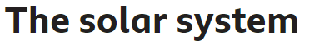
Use the link below to go to bbc bitesize – here there are videos and activities which I think you will enjoy.
https://www.bbc.co.uk/bitesize/articles/zk7fy9q
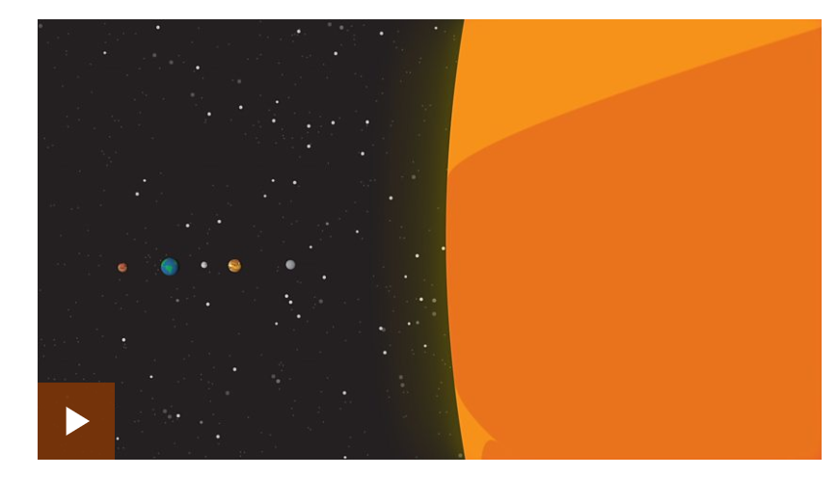
Solar system facts
- The Sun is a star.
- The Earth is one of eight planets that travel around the Sun.
- The planets are called Mercury, Venus, Earth, Mars, Jupiter, Saturn, Uranus and Neptune.
- The solar system is also home to lots of asteroids, moons, and dwarf planets such as Pluto.
One way of remembering the order of the planets from the sun is:
My Very Easy Method Just Speeds Up Nothing.
My (Mercury) Very (Venus) Easy (Earth) Method (Mars) Just (Jupiter) Speeds (Saturn) Up (Uranus) Nothing (Neptune).
Planet Earth facts
- The planet Earth is about 4.5 billion years old.
- Earth spins at 1000 miles per hour. It takes 24 hours to complete a full rotation.
- It's daytime on the side of the Earth that faces the Sun and nighttime on the side that is facing away.
- The Earth takes a year to travel around the Sun.
- Planet Earth has one moon, which is held in orbit by gravity.
Complete the activities on bbc bitesize.

Read the information about the planets. Can you make a fact file or a report about the different planets?