Year 6 - Spring Bank
Holiday Menu

Choose at least 6 of the activities below to complete over the Spring Bank holidays.
Make a time capsule with all the things, which has helped you through the last 9 weeks. | Go on TT Rockstars, try beating your high score and changing your rock status! | Log onto love reading  https://www.lovereading4kids.co.uk/  Can you read and make a book review on a book you have never read before? Whom will you inspire to tread?
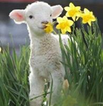  Go on a Spring walk. What new life can you see? | Can you make a giant pyramid? What will you make it out of? | Bake/Cook a recipe you’ve never made before….or a favourite (your choice!)
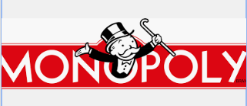  Design your own board game. Will you be the next famous person? It could be on line or a 3 D model. | Create your own PE game that you can teach to the Sports Leaders and Mr O’Brien | 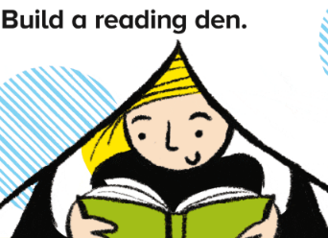  Make a reading den. Will you use fairy lights or torches?
Is there any of the past home learning which you need to catch up on? Have a look on the school website.
Websites:-
https://www.bbc.co.uk/bitesize/tags/zncsscw/year-6-and-p7-lessons/1
https://academystjames.com/year-6/

