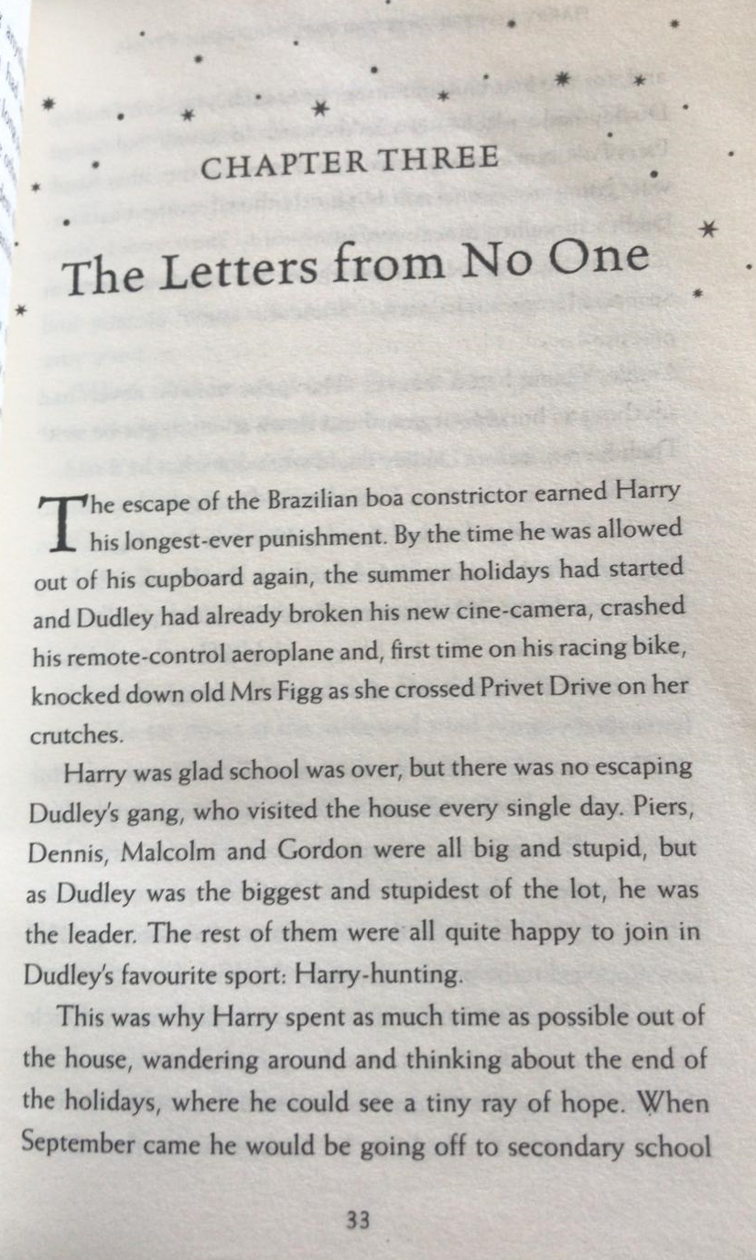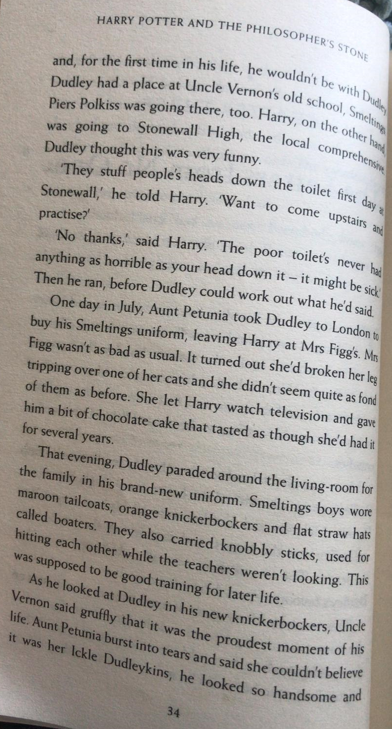

Questions
- Why was Dudley the leader of the gang?
- Read pages 33-34. Draw lines to match up the times on the left, with the relevant events on the right.

Summer holidays | Dudley walked around in his new uniform.
In July | Harry watched television at Mrs Figg’s house.
In September | The time Harry missed, as part of his longest-ever punishment.
In the evening | Harry wouldn’t be with Dudley, for the first time in his life.

- Find and copy the phrase on page 34, which suggests Uncle Vernon liked seeing Dudley in his uniform.

- Label the image of Dudley with phrases describing his uniform – there are some unfamiliar nouns, but can you work them out from how they are described or by researching? Is anything missing from the picture?

