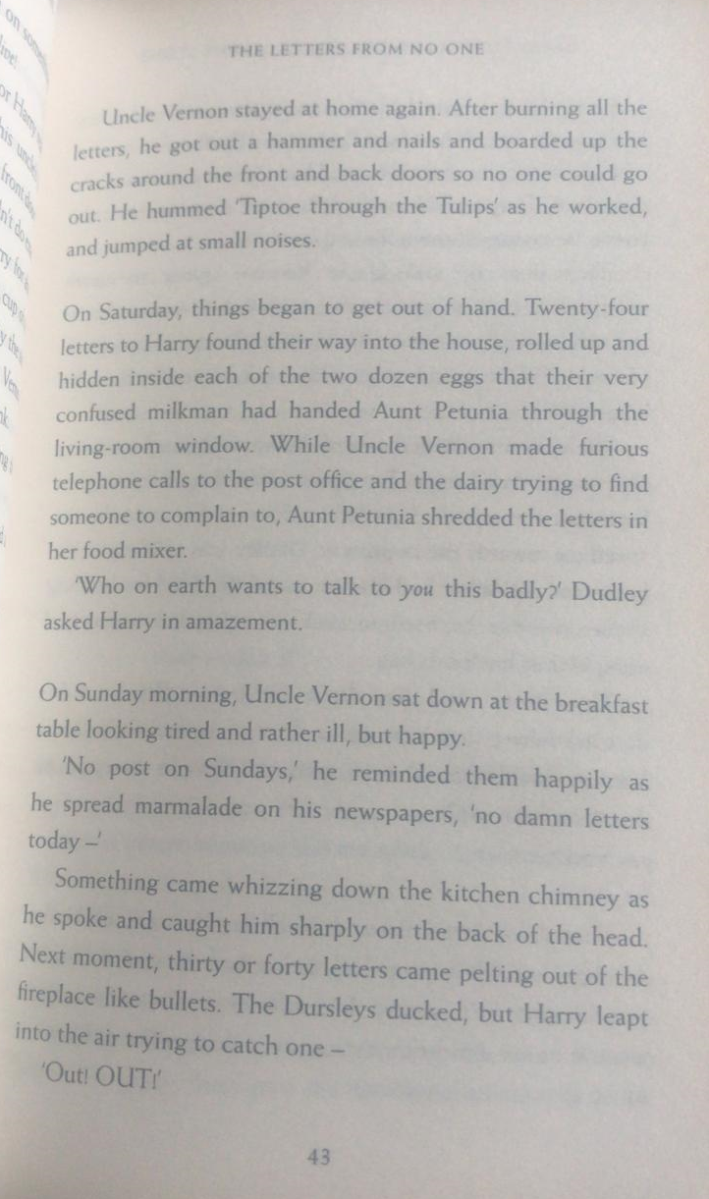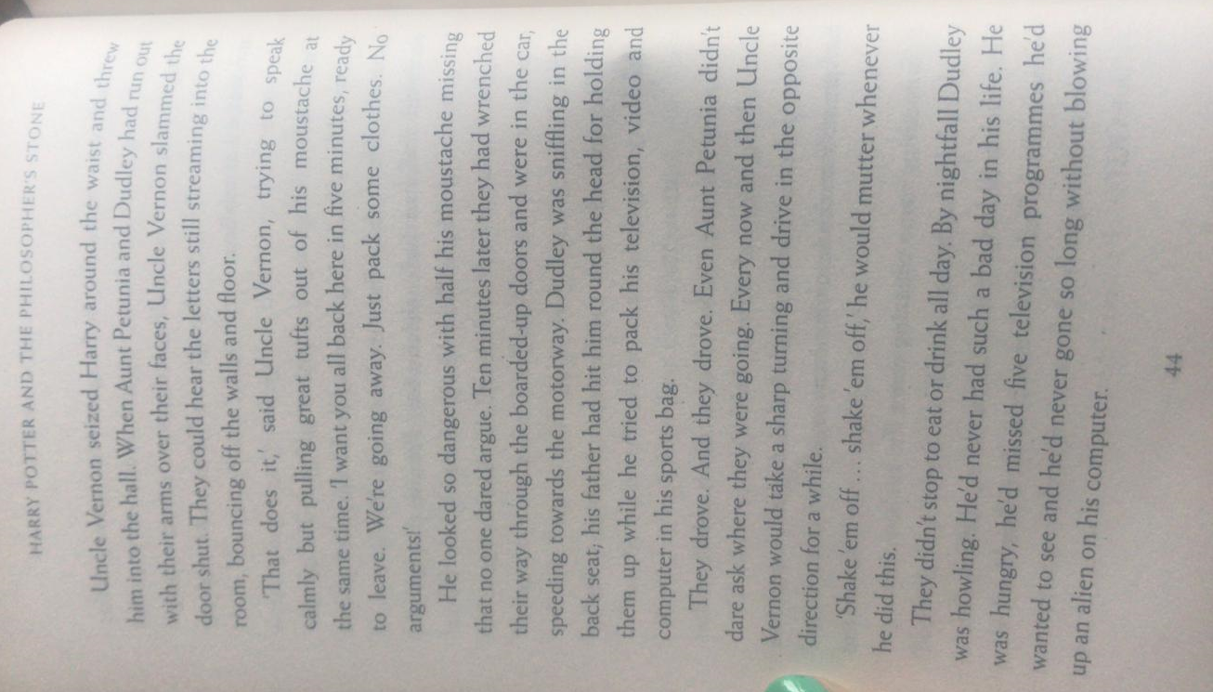
Questions
- Find and copy the phrase that tells the reader Uncle Vernon covered the gaps in the doors.
- Why do you think the milkman was confused?
- Find and copy the simile, which describes how the letters flew?
- How did they know letters were still streaming in, after they left the room?

 | true | false | Prove it
Things started to get out of control on Wednesday.
Aunt Petunia used kitchen equipment to destroy the letters.

Uncle Vernon spoke cheerfully, because there would no mail that day.

They kept going straight ahead, when Uncle Vernon drove.

It was the worst day Dudley had ever had.

