Thursday 21st May 2020
English
Invention

Fronted Adverbials
Adverbials are words or phrases that give more information to the sentence

I discovered fronted adverbials, earlier today.

A fronted adverbial is when the adverbial word or phrase is moved to the front of the sentence, before the verb. So here, 'earlier today' is a fronted adverbial.

Earlier today, I discovered fronted adverbials.

Task 1 - Watch the following clip to help you understand more. Have a go at the activity at the bottom as well.
https://www.bbc.co.uk/bitesize/topics/zwwp8mn/articles/zp937p3
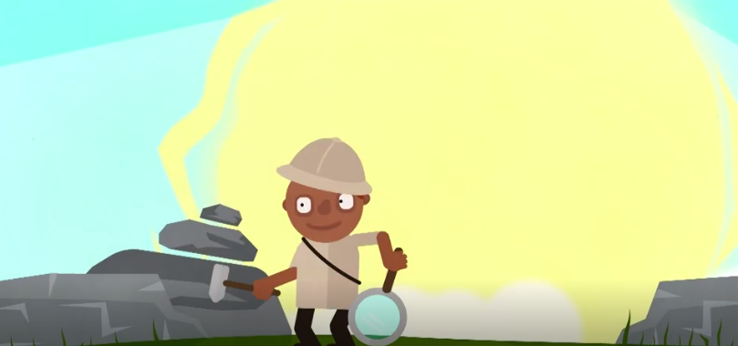

Task 2 – Continue writing your story from yesterday. Make sure to include some interesting fronted adverbials to start your sentences off in different ways…but not every sentence or it will become very repetitive!
Make sure not to ‘rush’ the problem section, go into detail about the battle the main character faces. You may even have two problems!
Task 3 – Editing. Re-read all the writing you have done so far. Use the system we use at school to edit your work correctly. You may add in some fronted adverbials if you think they fit.
Quick Write
Add
Take Away
Replace
Read Aloud

