Thursday 21st May 2020
Maths

Fractions of an amount
- To find a fraction of an amount, we must start with the whole number.
- We divide the whole number by the denominator (bottom number)
- And then times this by the numerator (top number.
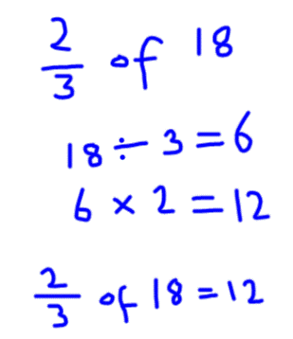

Watch the following clip and see if you can answer Gary Lineker’s fraction
questions.
https://www.bbc.co.uk/bitesize/clips/zs7g4wx

