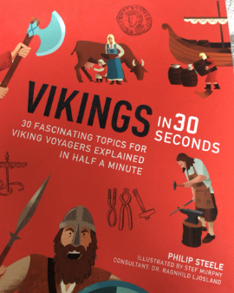
Reading
Thursday 7th May 2020

Rapid Retrieval
Pages 16-17
- Fill in the table to explain where each of these people were placed in society.

Thralls
Top

Jarls (Earls)

Kings

Karls
Bottom

- Why were Viking women seen as important?

- Find and copy three jobs the Thralls had to do?

- Find and copy the word that sets out the ranks of power in a society.

