Thursday – Week 8 – Mental maths
Long multiplication
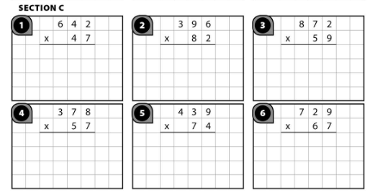
Long division. Remember to use repeated addition.
