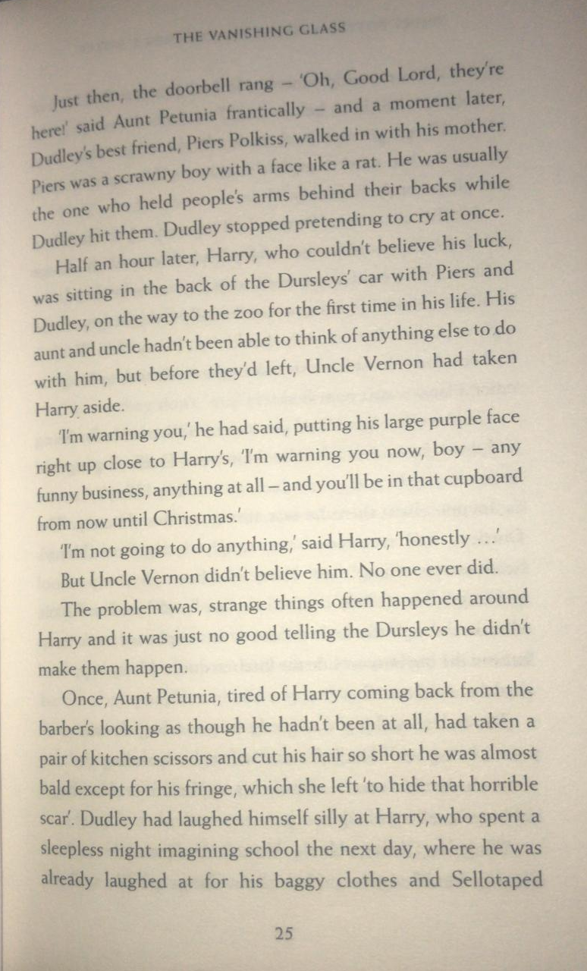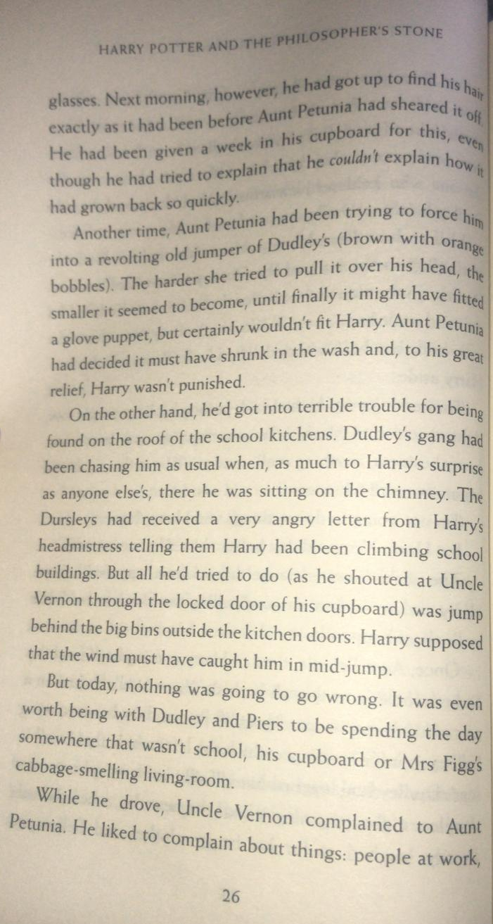

Questions
- Read the paragraph beginning, ‘Just then…’ on page 25?
Find and copy the adverb, which suggests one of the characters was rushing.
- What did Aunt Petunia use, when Harry’s hair grew too long?
- Which verb on page 26 is a synonym for ‘cut’?
- Why did Harry try to jump behind the big bins outside the kitchen doors? What happened when he tried this?

On these two pages, we have learnt about unusual happenings that involve Harry.
Create a comic strip (see example below), cartoon or act out (yourself, with toys or drawings) what happened in the scene with Dudley, his gang and Harry at school. You might include speech or thought bubbles to show what the characters were thinking and saying.
