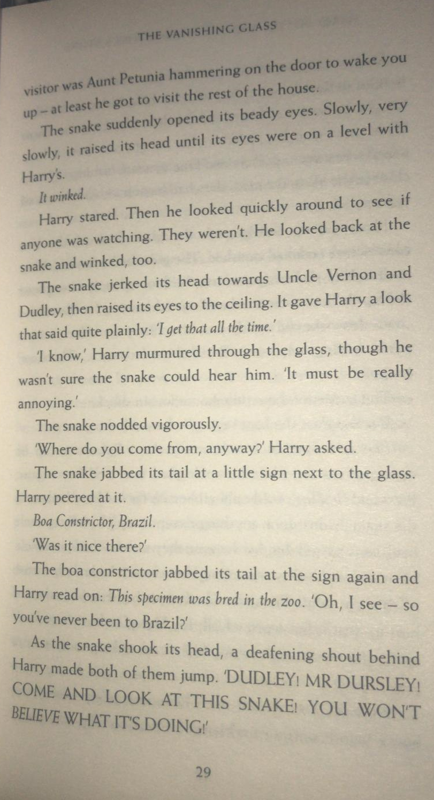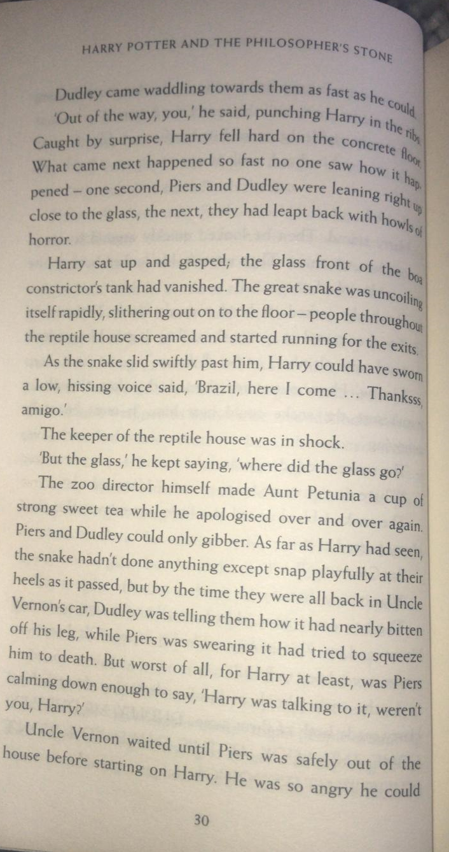
Questions
- Find and copy the adjective which suggests the snake’s eyes were small, round and gleaming?
- How did the snake let Harry know about his breed and origin?
- Why did Harry fall on to the floor?
- What was the reptile keeper most confused about?

If your adults at home give you permission!
https://www.youtube.com/watch?v=p2oIXSgqUjk
Watch this clip from the film version of Harry Potter. What do you notice is the same and different in this scene to the book? Think about the Story (what happens in the scene) and the Characters.
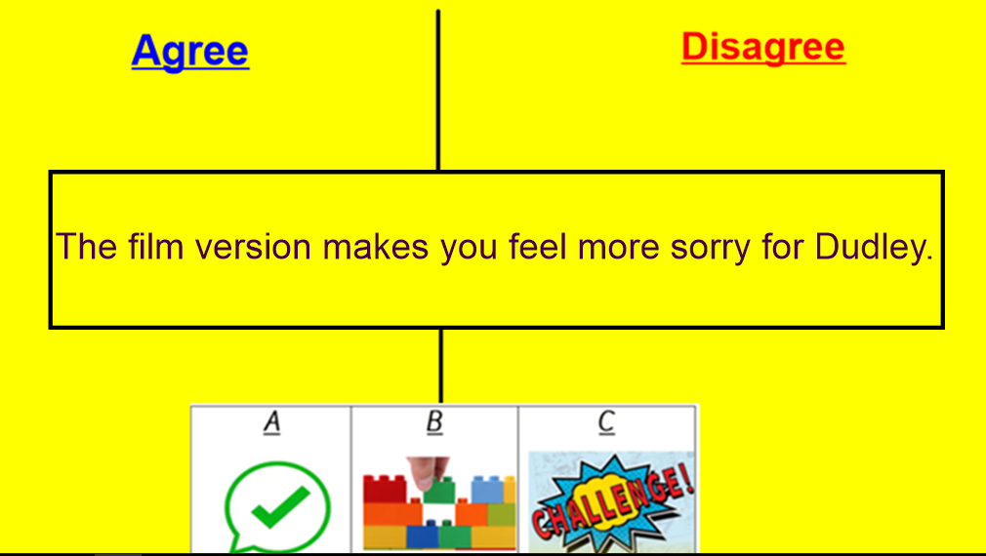
Consider reasons why you agree and disagree with statement. A debate will be started by the adults!

