Tuesday 19th May 2020
Maths
Comparing fractions
When fractions have the same denominator (bottom number), it is easy to compare them. You just need to look at the numerators (top numbers) to see which is larger/smaller.
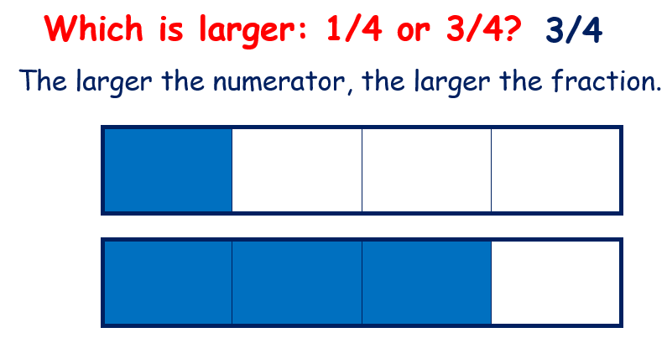

But when the denominators are different, it can become trickier to compare them. We must find equivalent fractions with the same denominator.
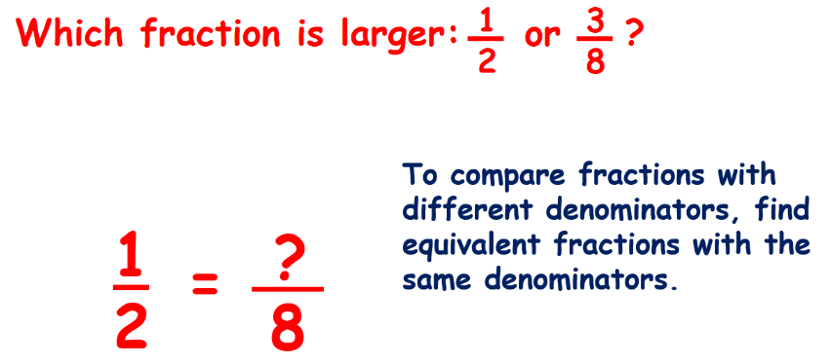

We do this by multiplying the top and bottom number with the same number to get the same denominator.

We now have 4/8 and 3/8.
4/8 is larger than 3/8 but we have to put the fractions back to their original form.
Therefore, 1/2 is larger than 3/8.

Watch the following video to help you understand more.
https://www.youtube.com/watch?v=bj5fSn96Cns
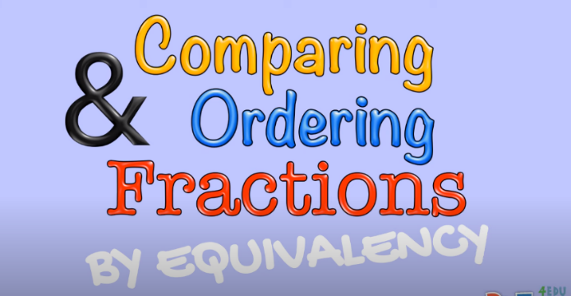

If you are still struggling, you may want to use fraction strips to help you.
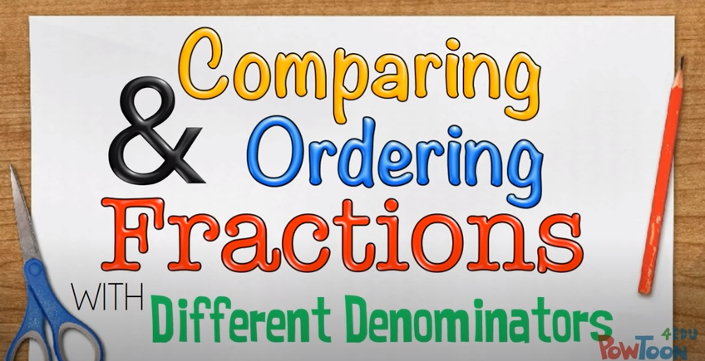
https://www.youtube.com/watch?v=nH7s9SIjwus

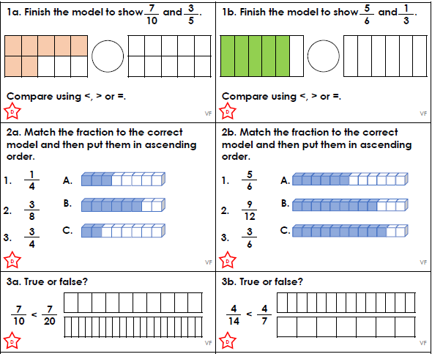
Now have a go at these questions.

