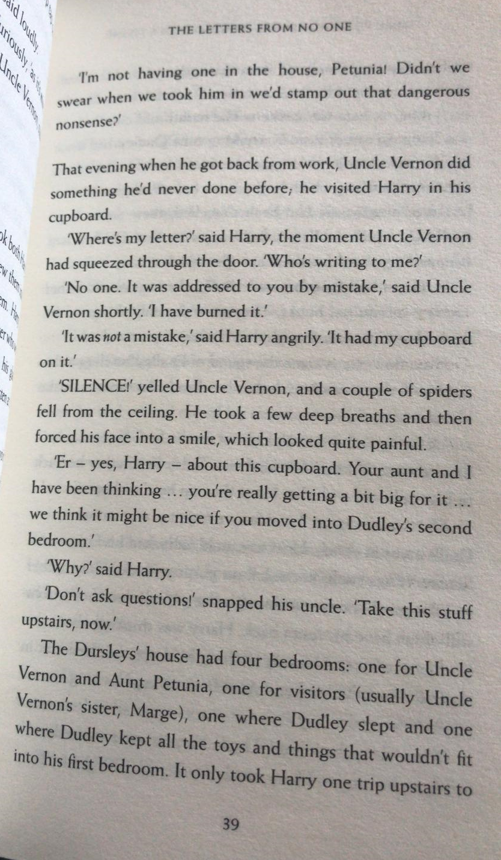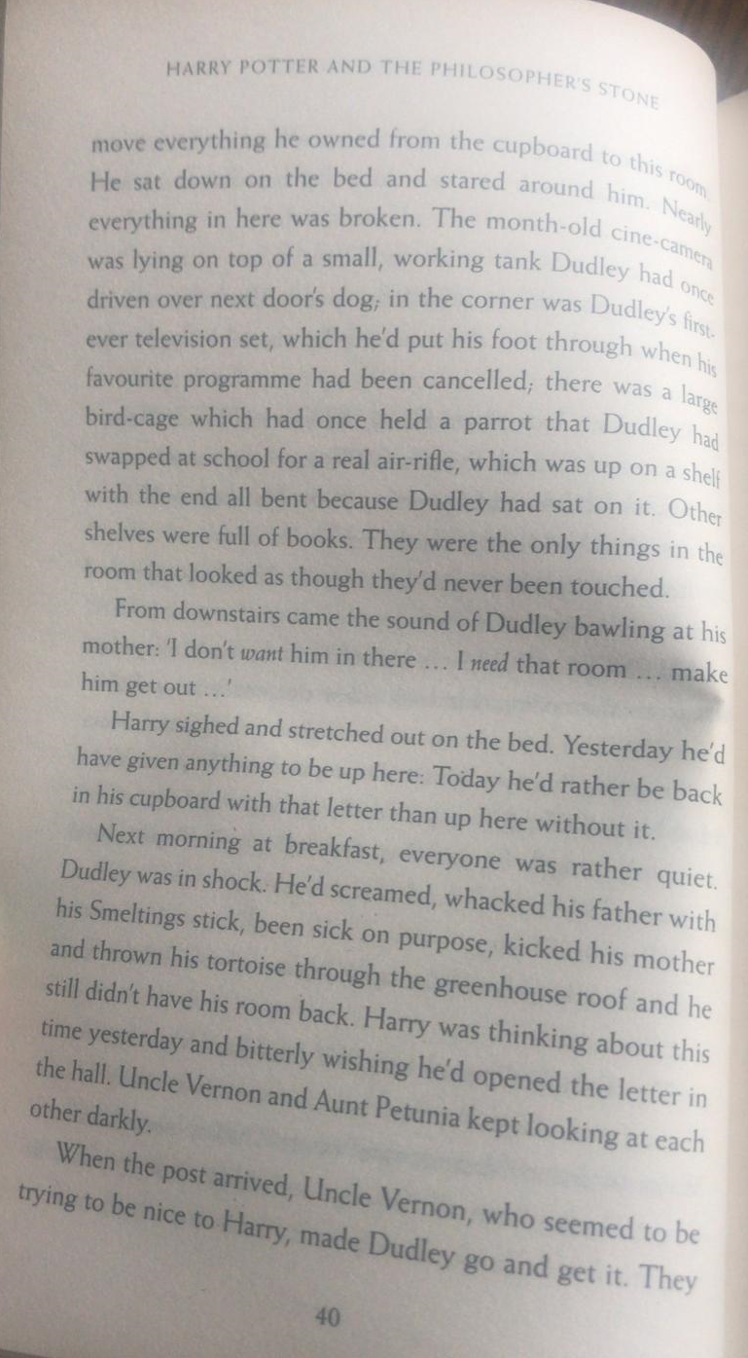
Questions
- When did Uncle Vernon visit Harry?
- How do we know that Uncle Vernon wasn’t happy, when he spoke to Harry? Write two reasons.
- How many times did Harry have to walk upstairs with his belongings? Why do you think it was this number of times?
- What did Harry wish he had done yesterday?
- Why do you think Uncle Vernon seemed to be trying to be nice to Harry?

Share your ideas with us. Remember to think about what you have read on pages 39-40, and include those details in your answer.
