Week 6 – Tuesday
Decimal sequences – finding the next two terms.

Look at the decimal sequence below. What do you notice about the sequence? What is happening to the numbers each time?
4.1 4.4 4.7 5 _ _

How could we find the next two numbers in the sequence?
We need to find the difference between two of the terms adjacent to (next to) each other.
let’s find the difference between 4.1 and 4.4
4.4 – 4.1 = 0.3

That means our sequence is increasing by 0.3 each time.
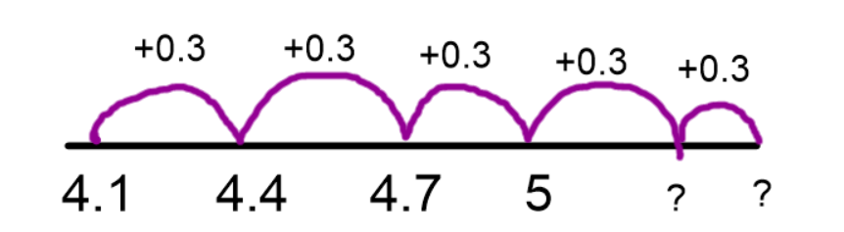
So our missing numbers have to be:
5 + 0.3 = 5.3
5.3 + 0.3 = 5.6

Sometimes the sequence may decrease each time.
Look at this example:
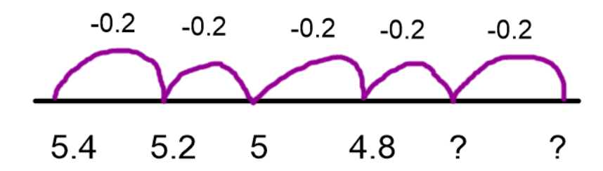
This time, the difference is -0.2
We are decreasing by 0.2 each time.
4.8 – 0.2 = 4.6
4.6 – 0.2 = 4.4

Task – complete the following decimal sequences. Draw the number line if it helps.
- 5.4, 5.5, ______, 5.7, 5.8, ______, 6

- 6.2, ______, 6.6, 6.8, ______, 7.2, _____

- 1.7, 2, 2.3, ______, ______, 3.2, 3.5

- 15.5, 15.9, 16.3, ______ , 17.1, 17.5, ______

- 0.65, _____, 0.63, 0.62, ______, ______, 0.59

- 2.22, _____, 2.26, 2.28, 2.30, ______, 2.34

- 16.9, 16.4, ______, 15.4, 14.9, ______, 13.9

- ______, 6.5, 6.2, 5.9, ______, 5.3, ______

- 8.11, 8.22, ______ , 8.44, 8.55, ______, _____

- 5.62, _____, 5.70, _____, 5.78, 5.82, _____

