Morning Maths
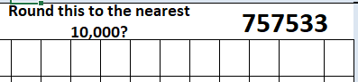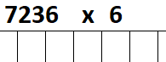
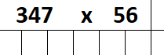
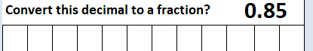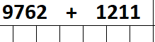
Main Activity – applying calculating with decimals to real life problems.
 |  | Hull | York | Leeds
Adult | single | £12.50 | £15.60 | £10.25
 | return | £23.75 | £28.50 | £19.30
Child | single | £8.50 | £10.80 | £8.25
 | return | £14.90 | £17.90 | £14.75

- Look at the table above
- What is the total cost for a return journey to York for one adult and two children?
- What is the total cost for a return to Hull and a single to Leeds for four adults?

- Colin lived in Scotland and was going to take his caravan on holiday to France. On the first day he travelled 472.87 miles to Portsmouth. He got a ferry which travelled 73.92 miles. He then got off the ferry and drove 134.56 miles to the camp site.
- How far did Colin travel to the camp site?
- He drove a scenic way home which added another 93.45miles to his journey. How far did he now travel?

- Michael Schumacher can travel at 166.35 mph in his Ferrari. How far can he travel in 5 hours?

- Joanna went to wash her car. She parked her car 56.84 metres from the tap. Her hose was 50.07 metres long. How much closer would she need to park her car so that the hose could reach it?

- The temperature in the classroom was 21.8 °C. Claire left the door open and the temperature dropped by 3.7 °C. Rohan turned the radiators up and the classroom temperature rose by 5.7 °C. What was the temperature now?

