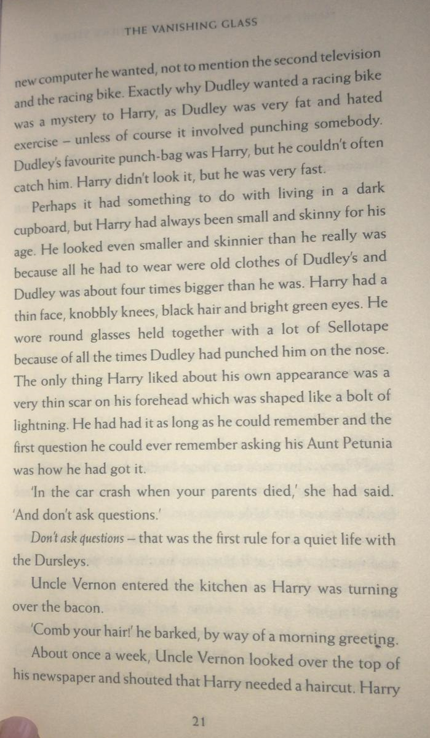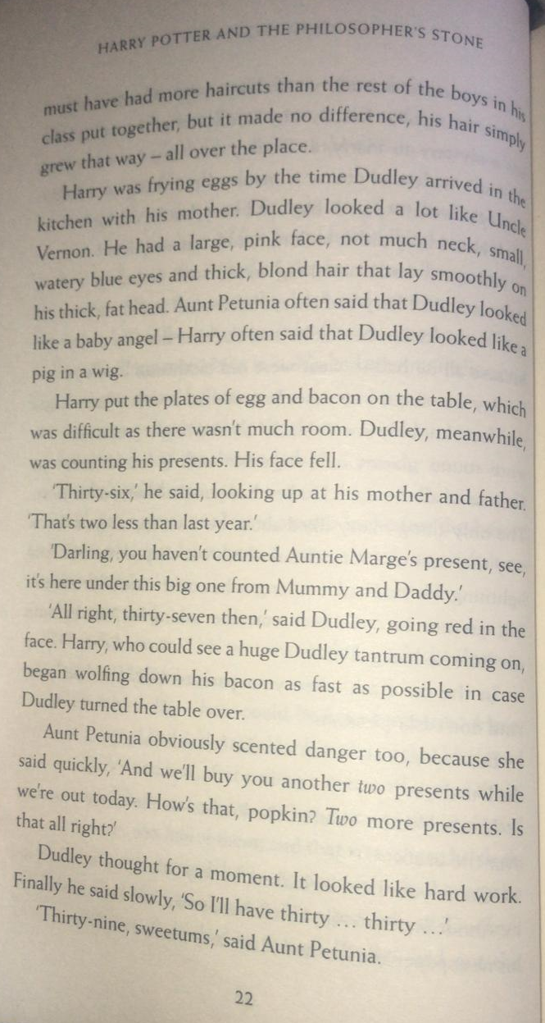

After reading pages 19 and 20, complete the Venn diagram for the characters Harry Potter and Dudley Dursley.
The adjectives you write could be used to described their appearance, personality. Any words that are appropriate for both Dursley and Harry go in the middle of the Venn diagram (for example, the noun – ‘boy’).
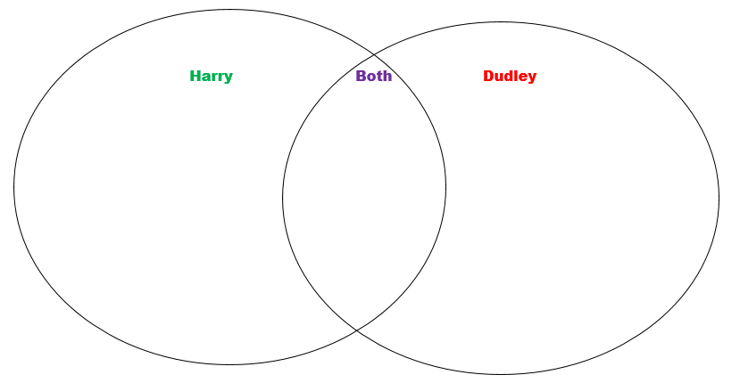
Once you have completed your Venn diagram, write at least two comparative sentences using whereas/unlike, both/similar to.
Examples:

Mr Brownsell prefers playing football, whereas Mr Wallis enjoys cricket.
Unlike Mr Wallis and Mr Brownsell, who have no pets, Miss Petty has a dog called Rico.

Both Mr Wallis and Miss Petty enjoy going to the gym to keep fit.
Mr Brownsell is similar to Mr Wallis, because he loves eating!

