Science W/C 18.5.2020
After watching the video of the book which Miss Petty read, you should know more about the water cycle. Can you explain to your family members about what happens to the tiny water droplet?
Watch this video to support your learning even further:
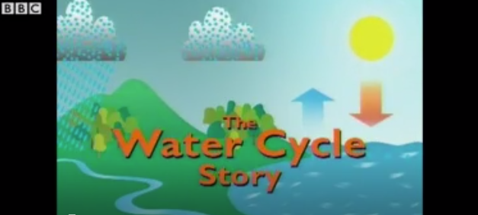

Please can you do the following 2 science experiments to support your knowledge of the water cycle.
**YOU WILL NEED YOUR GROWN UP TO HELP YOU- DO NOT DO THESE EXPERIMENTS BY YOURSELF**
First experiment:
Observation over time. What do you notice? Please put on your window where the sun will be able to shine on it (parent permitting). Draw the water cycle onto the plastic zip bag and label.
Do you see the water droplets? What else do you notice? Take photos when you notice a change!

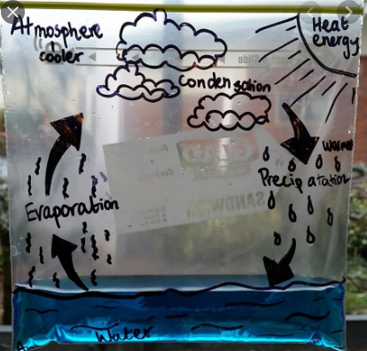

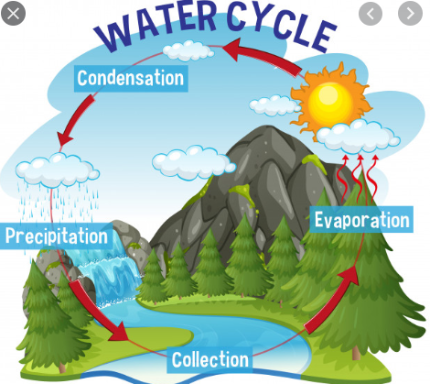

(Use this diagram to label your plastic bag water cycle experiment!)

Second experiment
PLEASE DO NOT DO THIS BY YOURSELF- HAVE A PARENT TO HELP YOU
You will need:
- A plastic container with a lid
- Hot water
What do you notice? Do you notice the condensation on the lid? Shake the lid, does it look like it’s raining? (That’s the same process of precipitation)
Take photos and discuss it with your parents what you notice.
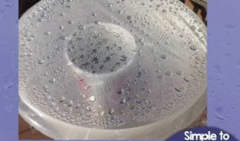

Fill the container half way with hot water
(YOUR PARENT WILL DO THIS-NOT YOU!)
Place the lid on the container. Wait until you can see the condensation. Take the lid off and shake it. What do you notice? Repeat as many times as you like.

Draw your experiment and label. Explain what you have noticed. Or you can film your experiment and explain what you have learnt.

