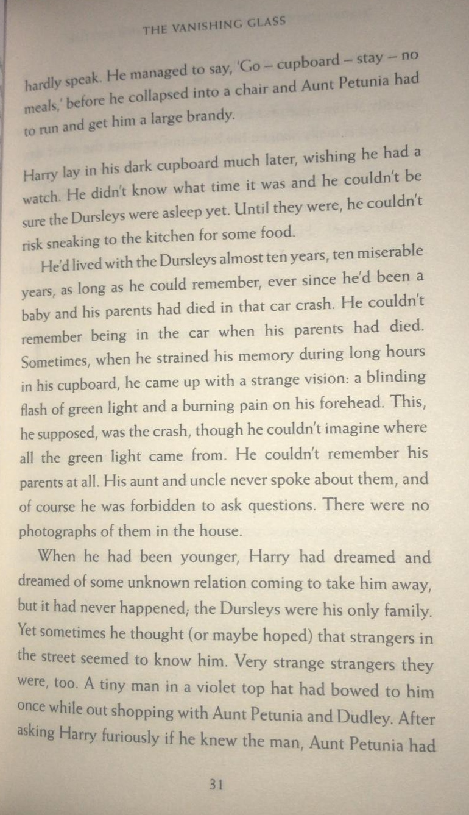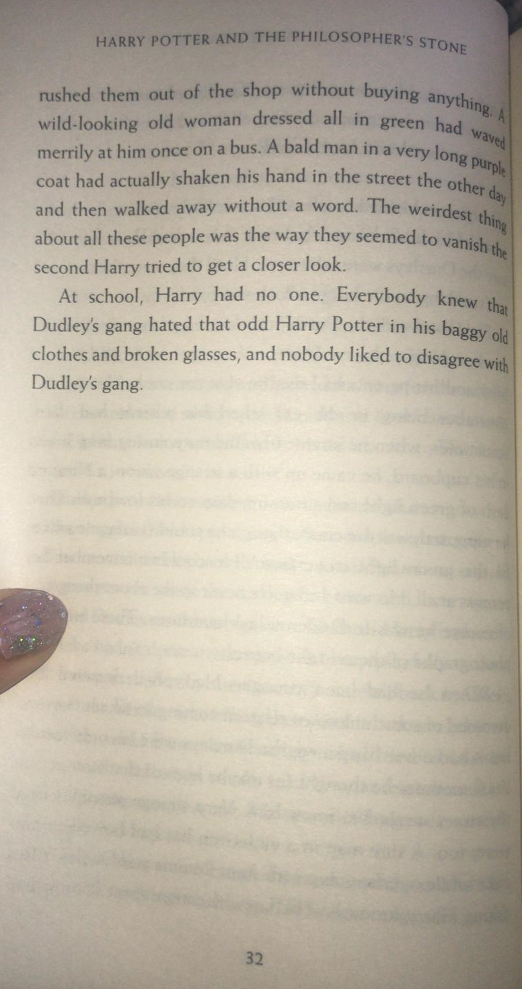

Questions
- Write two reasons why Harry wished he could have a watch.
- Read the paragraph beginning, ‘He’d lived with the Dursleys…’
What was Harry confused about?
- Find and copy the synonym for ‘not allowed’ on page 31.
- What was the strangest thing about the people Harry saw?

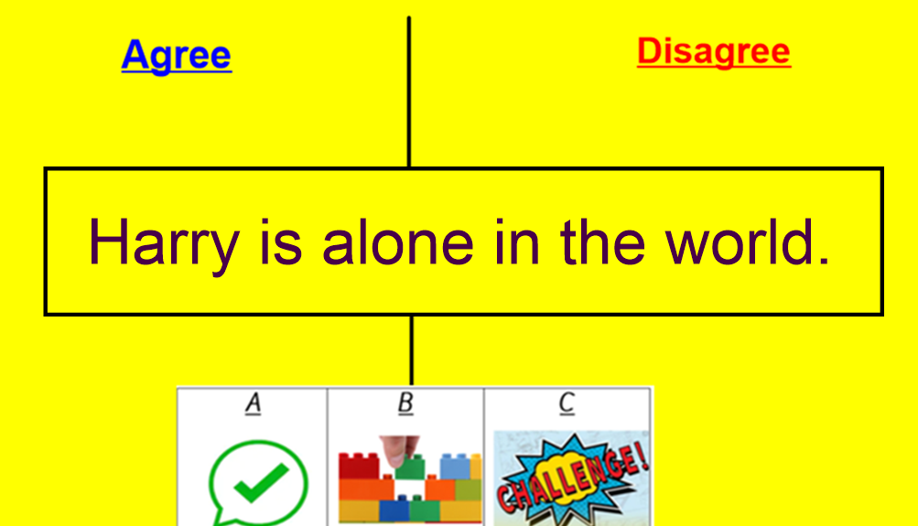
Consider reasons why you agree and disagree with statement. A debate will be started by the adults!

