**Wednesday 20th May 2020**

**Maths**

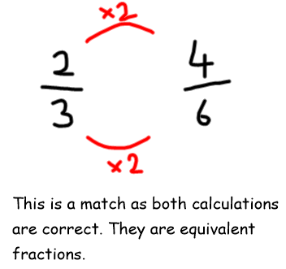**Recap – Finding equivalent fractions**

Use multiplication and division to match the equivalent fractions. I have modelled an example for you.

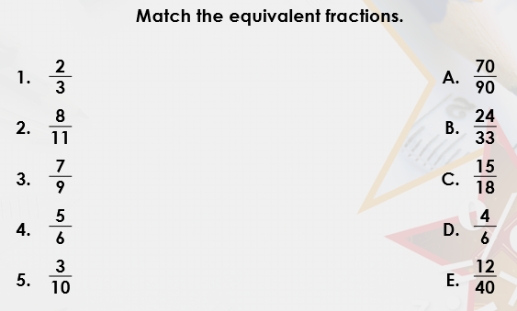

Looking at 2/3 I know I need to link my 3x table with the other denominators. I can see the denominator 6 so I can test this one.

I need to times the numerator and denominator by the same number.

nu

