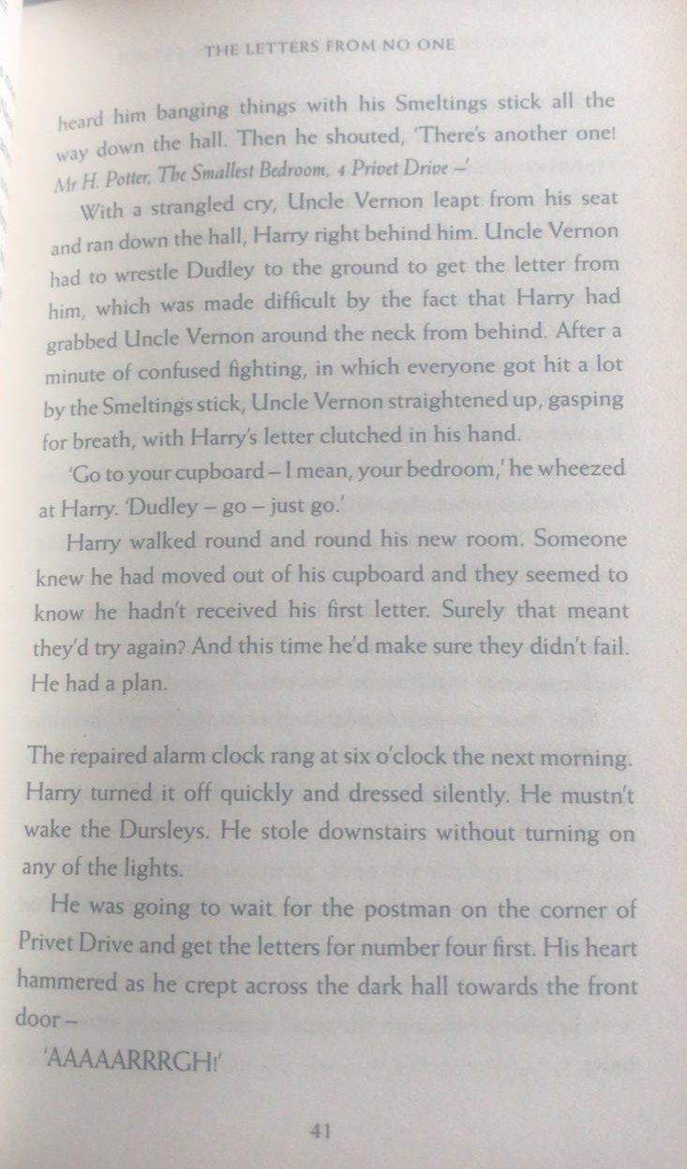
- How has the address changed from the first letter that arrived?
- What was Harry’s plan to make sure he got the letter the next morning?
- Why did Uncle Vernon stay at home and not go to work?
- Write the three ways in which the letters came into the house on Friday.

Create a comic strip of the events from Harry creating his plan to letters arriving on Friday. Use the text to decide the key moments, correct information and characters, include thought/speech bubbles and captions. I have included the first caption. Add more columns, if you want!
Harry turned off the alarm and silently crept down the stairs in the dark.

