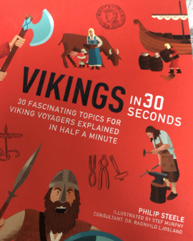
Reading
Wednesday 6th May 2020

Statement | True/False? | Prove It
The Viking alphabet was long and difficult to understand.
The Vikings had many different names.
Vikings was the term given to Scandinavians over 2000 years ago.
The Old Norse language is still used today by many different people.

