Wednesday week 8 History

What did the ancient Egyptians believe in?
https://www.bbc.co.uk/bitesize/articles/zdq3gwx

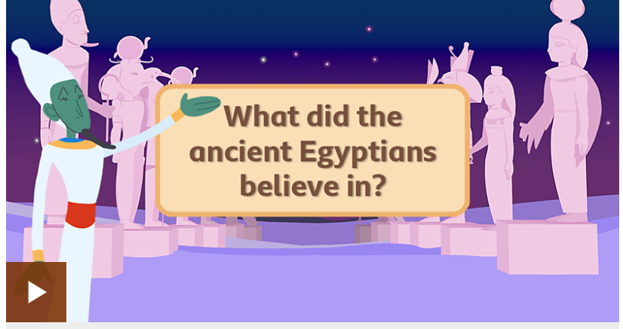

Ancient Egyptian gods
The ancient Egyptians had many gods. Gods created the universe and maintained order, but they were also involved in everyday life.
Egyptians believed that a long time ago, only chaos existed. Out of chaos a hill emerged (called the Benben). The first god, Atum, was sitting on the hill.
Atum, realising he was alone, created two children called Shu and Tefnut. His children left to create the world. Shu and Tefnut were away for a long time so Atum sent his eye to look for them.
Shu and Tefnut returned with Atum's eye and he was so grateful the eye started crying. The tears dropped to the earth on the hill and from them the first humans were created!

Practise
There are lots of fun ways to practise your historical knowledge of ancient Egyptian gods online and offline.
Here are a few you could try.

Activity 1
Can you name the ancient Egyptian gods?
Try to match each ancient Egyptian god with their picture.
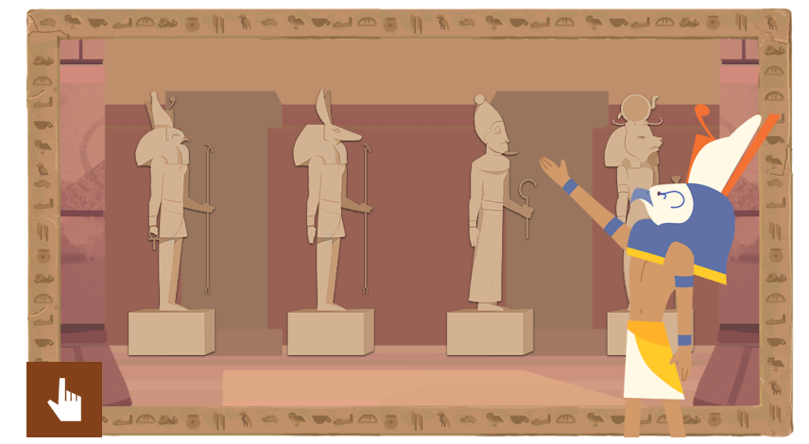
Use the quick facts guide to the Gods – Can you make top trump cards?

