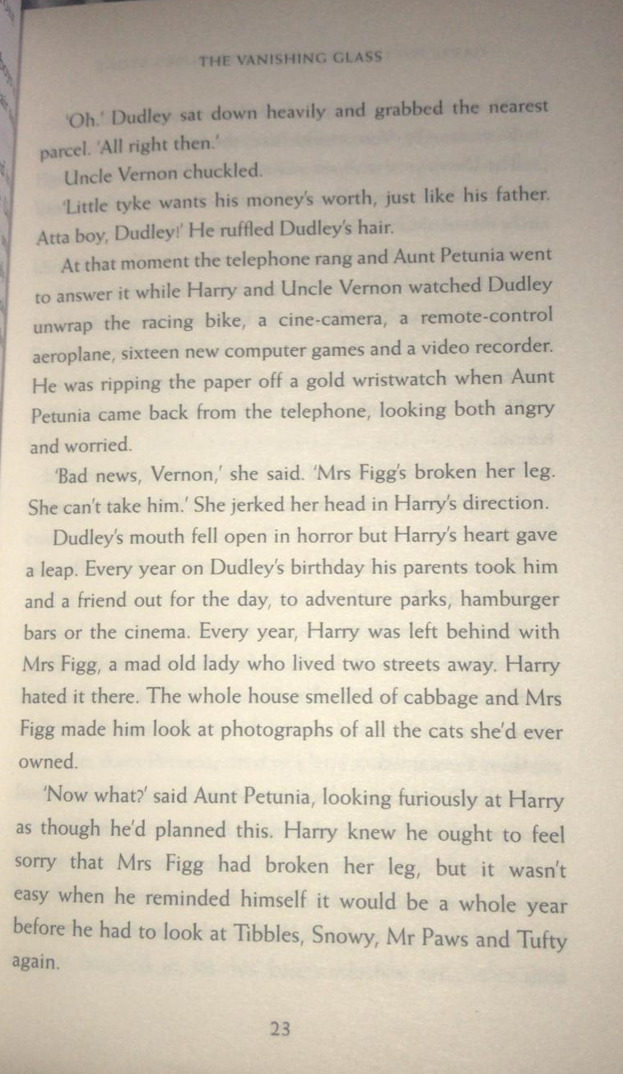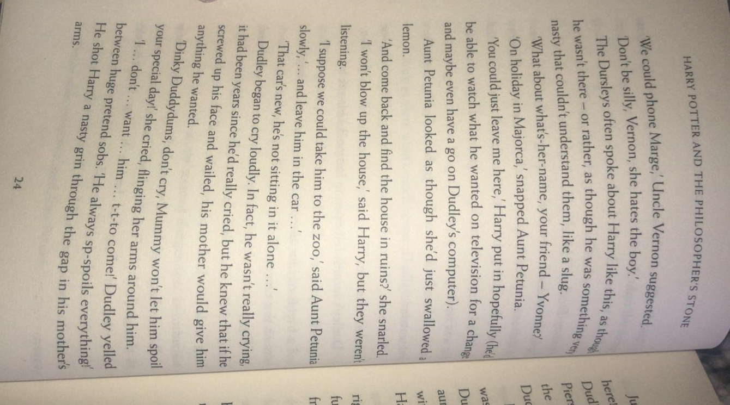
Questions
- Which phrase on page 23 suggests that Harry was pleased?
- Write two reasons why Harry hated going to Mrs Figg’s house to be looked after?
- Why couldn’t Yvonne look after Harry?
- Why did Dudley cry?

Decision Wheel
On the next page are four different options for the Dursleys – add good (+) and bad (-) reasons for each one. Then, use these reasons to explain which is the best option for them to choose.
Are there any other options they could consider?

Remember, reasons could be better for them, Dudley, Harry or all of them.

