Week 6 Friday
Morning Maths

- 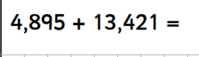 2. 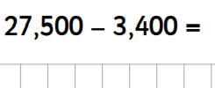
3. 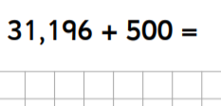 4. 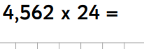
5. 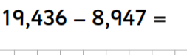 6. 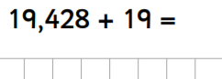
7. 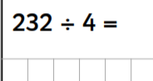 8. 