Week 6 Thursday
Decimal sequences
Following on from yesterday’s work – see if you can answer these more tricky sequences.
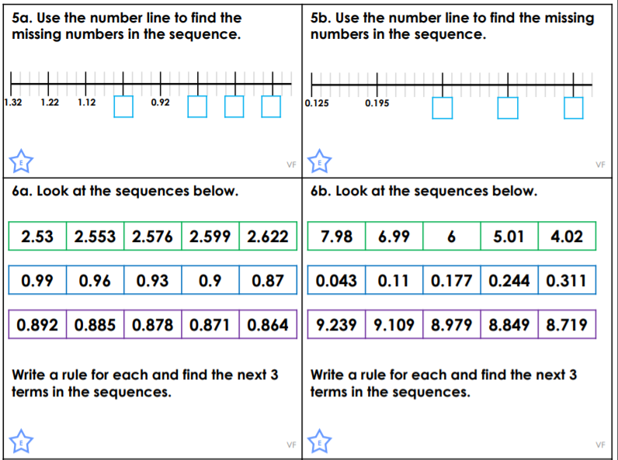
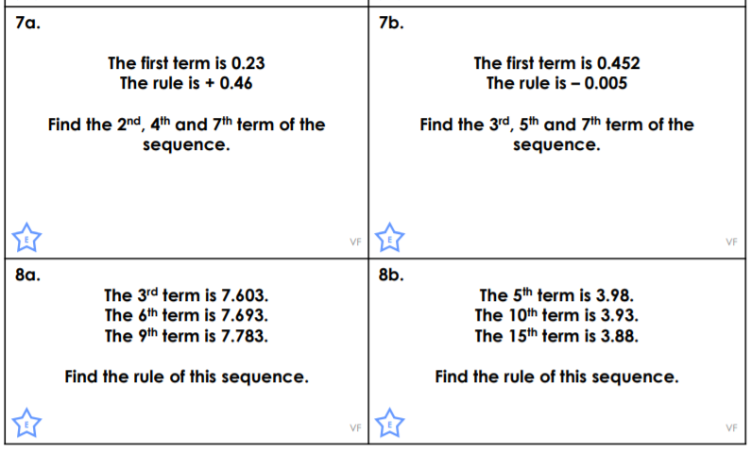
Challenges
