Week 6 – Tuesday
Morning Maths

- 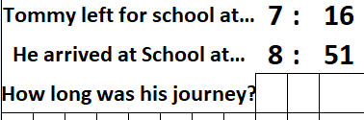

- 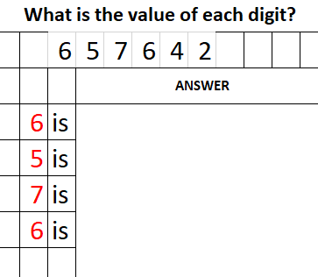 3. 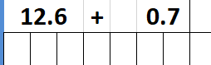

4. 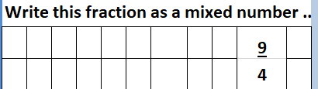
5. 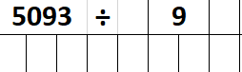 6. 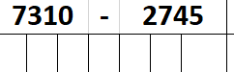
7. 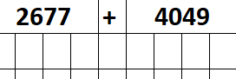 8. 