Week 6 – Lesson 2 – Tuesday
Subordinate clauses

Re-read the WAGOLL of Beowulf and see if you can identify / pick out any of the subordinate clauses.

What is a subordinate clause?
A subordinate clause contains a subject and a verb, but it needs to be attached to a main clause because it cannot make sense on its own. For example:
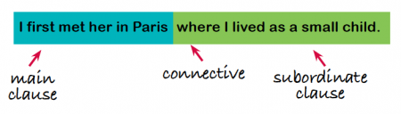
Main clauses don't always have to come before subordinate clauses in sentences. For example:
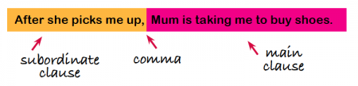
A subordinating conjunction and its clause can go either before or after the main clause (depending on what is to be emphasized).
- If you need money, just let me know.
- Just let me know if you need money.
- Although the necklace was expensive, she bought it.
- She bought the necklace although it was expensive.
Notice which sentences have a comma. If the subordinate clause starts the sentence, there is a comma after the subordinate clause.

Look at these sentences from the WAGOLL. Underline the main clause in each sentence and circle the connective (subordinating conjunction).
Then re-write the sentence with the subordinate clause in a different place.
Sentence from the text – underline the main clause. | Re-write the sentence with the subordinate clause in a different position.
Inside, the men ate and drank until they fell asleep. | Until they fell asleep, inside, the men ate and drank.
Across the moor, a foul monster crawled from a swamp.
Aboard a seaworthy ship, he sailed the seal-bath to Denmark with fourteen handpicked warriors.
When Beowulf arrived, sudden hope warmed the old king’s heart.
As darkness swallowed the light, the swamp bubbled and Grendel rose.
Without a weapon, Beowulf pounced, grasping the monster’s arm.
By the next morning, the news of the great fight at Heorot had spread throughout the land.

