Week 6 – Wednesday
Morning Maths

- 2. 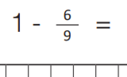
3. 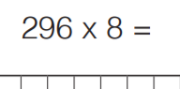 4. 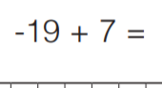

5. 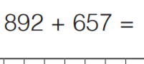 6. 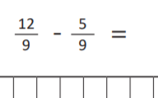

7. 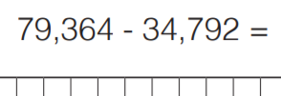
8. 