Week 6 – Spearation

Re-cap – Soluble/insoluble
Match the key words from last week’s video to their definitions
Substance

Dissolve

Transparent

Liquid

Solution

Soluble

Insoluble
to become incorporated into a liquid so as to form a solution.
a substance that flows freely but is of constant volume
able to be dissolved, especially in water.
allowing light to pass through so that objects behind can be distinctly seen
a liquid mixture in which the minor component (the solute) is uniformly distributed within the major component (the solvent).
incapable of being dissolved.
a particular kind of matter with uniform properties.

What is separation?
Use the following websites to find out what separation is:
https://www.bbc.co.uk/bitesize/topics/zcvv4wx/articles/zw7tv9q
https://www.bbc.co.uk/bitesize/clips/zb9c87h
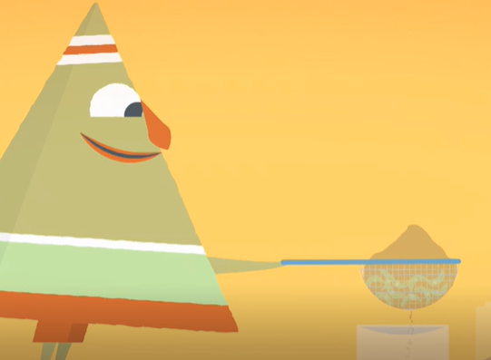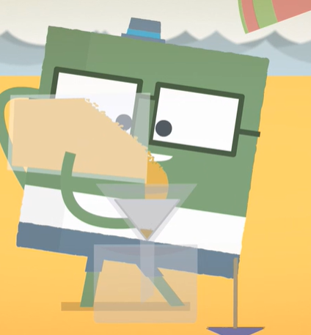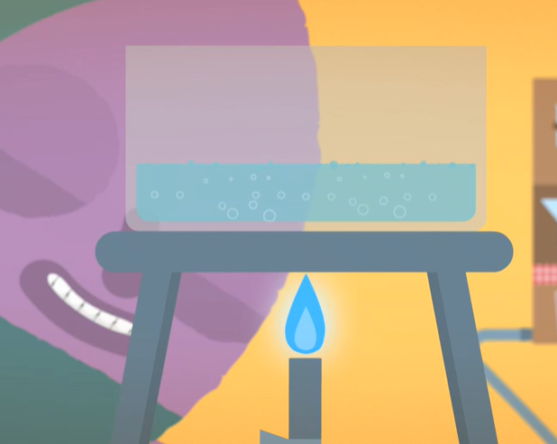
Create a poster to teach other children all about separation. Explain what it is and show what methods you could use to separate different mixtures.
Will all separation methods work for every mixture?

