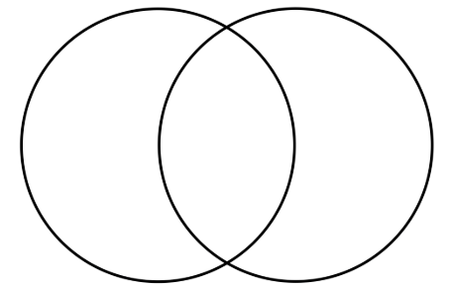

1 | Howard Carter is a thief
2 | Tutankhamun’s tomb should have been left alone
3 | Everyone should have access to the treasures in his tomb so it was right to take them
4 | It is wrong to break into tombs

