Week 9 – Day 5 – SPAG
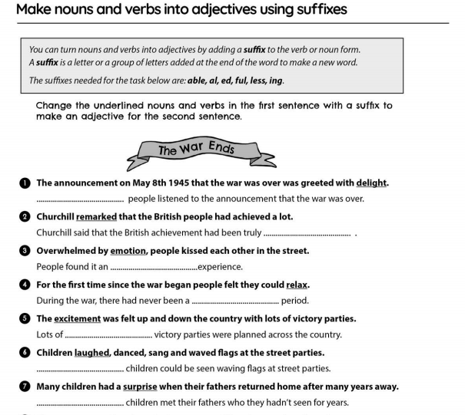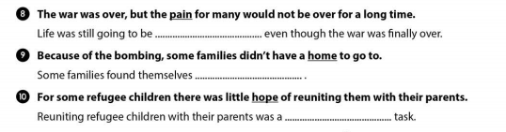

If you need any reminders about ellipsis, please use the link to go to bbc bitesize. https://www.bbc.co.uk/bitesize/topics/zvwwxnb/articles/zpgjy4j
