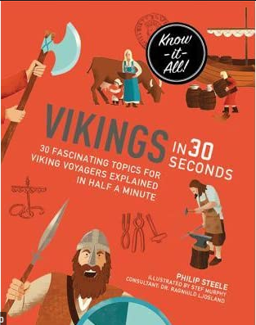
Words of the week
Can you find out the definition of the following words?
Try use them in a sentence of your own.
scarcely pg.32 –

brutal pg. 32 –

forged pg. 40 –

conical pg. 42 -

bribe pg. 44 -

