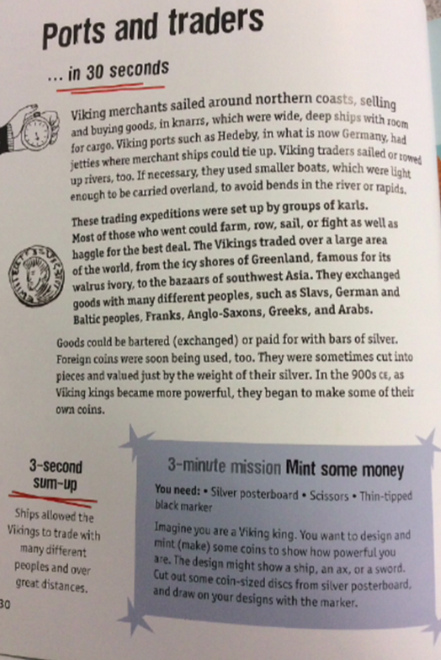

Why were smaller boats needed for Viking traders?

Why do you think Viking kings made their own coins?

**Wring it out**

Why would Vikings use bars of silver to trade?

Why would jarls not have to do this job if trading was so important?