Year 5 Spring Bank
Homework Menu

Choose at least 6 of the activities below to complete over the Spring Bank holidays.
Go on TT Rockstars, try beating your high score and changing your rock status! | Make a weather report.  Keep track of what the Spring weather is like. You could draw a picture or record a video. | Build our own Viking Longhouse!  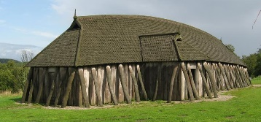 | Art/DT  Draw/paint/make something that will put a smile on someone’s face during this tough time
Bake/Cook a recipe you’ve never made before….or a favourite (your choice!) | The Vikings created the game ‘Nine Men’s Morris’. Have a go at playing online!  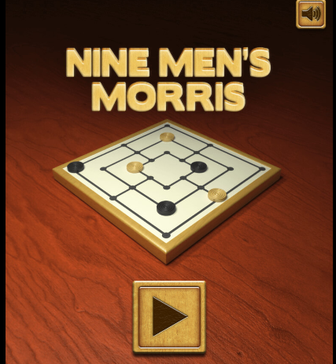 | Go on a Spring walk. What new life can you see? | Write a book review  It could be one we are reading together or one of your own!
Build your own 3D Viking mythical monster! You can use junk modelling to create it  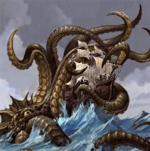 | Use what you know from Scratch so far to create your own video game based on Space! | Create your own PE game that you can teach to the Sports Leaders and Mr O’Brien | Complete your own fun Science experiment!

Useful websites:
Science Experiments - https://www.businessinsider.com/8-awesomely-simple-science-experiments-you-can-do-at-home-2016-7?r=US&IR=T
Scratch - https://scratch.mit.edu/
Viking Monster Ideas - https://vikings.mrdonn.org/monsters.html
Nine Men’s Morris Game - https://toytheater.com/nine-mens-morris/ Type in Google ‘Nine Men’s Morris Online’ an click the top link.
Viking Longhouse Information - https://www.bbc.co.uk/bitesize/topics/ztyr9j6/articles/ztqbr82#z9bxtfr

