Week 6 – Monday
Decimals on a number line
Here is a number line 1 to 10. In between each of the numbers on the number line are decimal numbers. We just don’t always write them down.
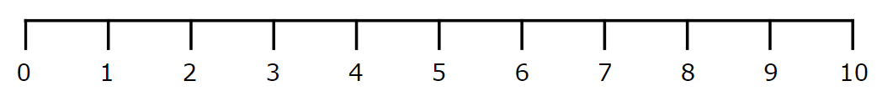

In between the 7 and 8, there are other decimals.
For example:
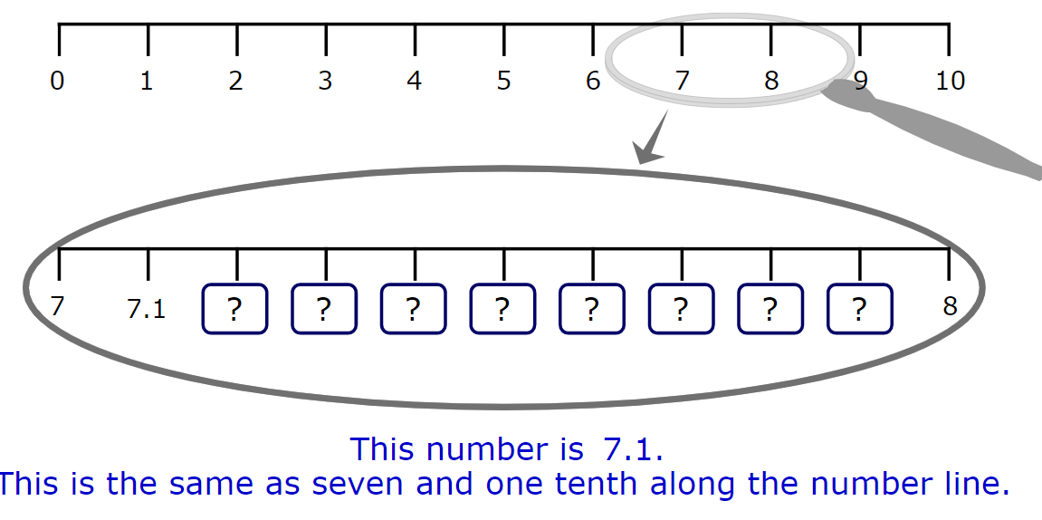
Next, there is 7.2, 7.3, 7.4… each decimal increases by 0.1 or one tenth.
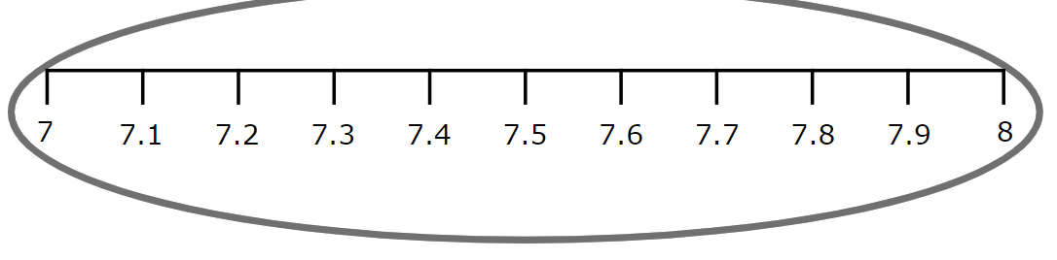

Look at this number line
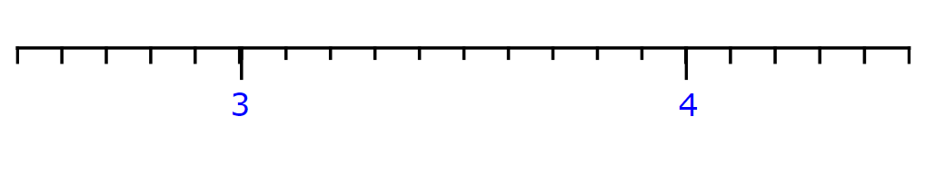
Which decimals would go between 3 and 4?
The number line is divided into tenths so each mark is worth one tenth.

3.9
3.1
Task 1 - Complete the number line for the decimals between 3 and 4.

Task 2 - Place the values of A, B, C and D on the number line above in the correct places between 5 and 6.
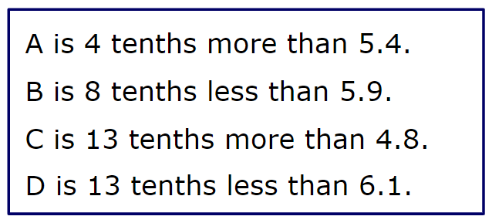

Inbetween the tenths, we can find even more deciamls.
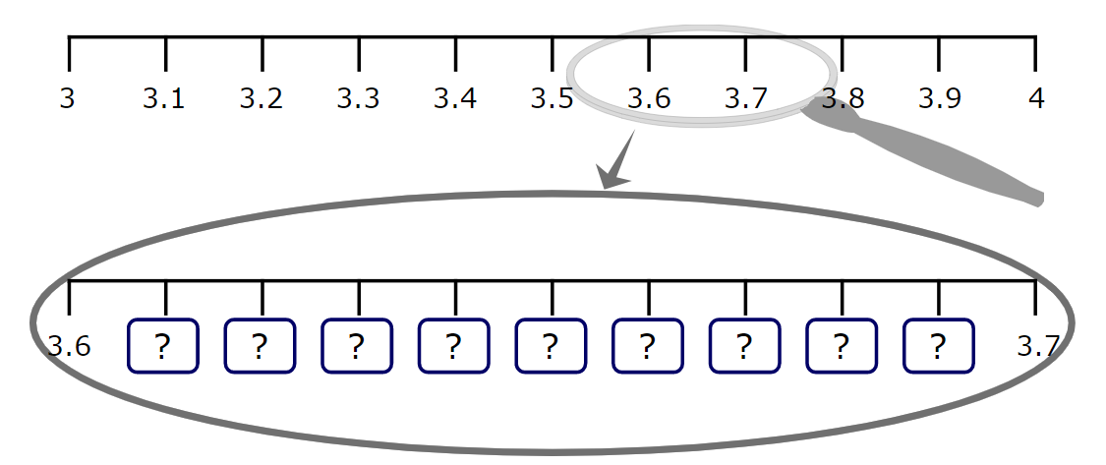
Let’s look between 3.6 and 3.7.
We find hundredths in between the tenths.
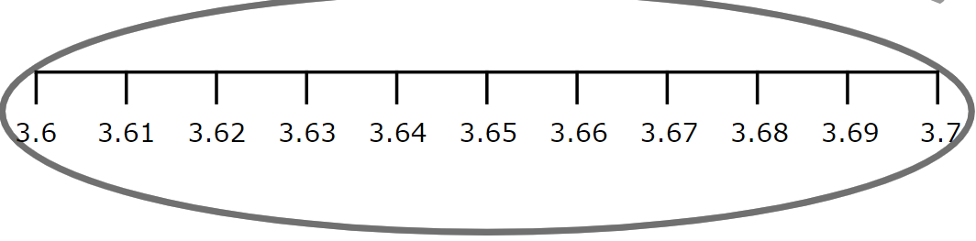

Look at the number line below.

Task 3 - Place the following decimals onto the correct place on the number line above.
2.12, 2.14, 2.18

Task 4 - Look at the number line below and place A, B, C and D in the correct place

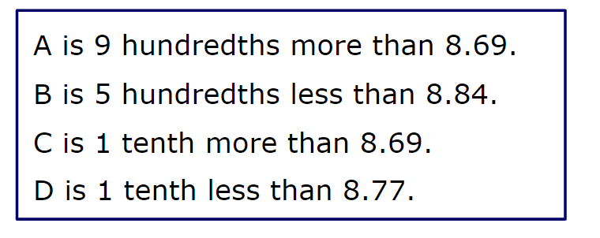

For more practise with sequencing decimals use the link below and compelte the lesson on mymaths.
https://app.mymaths.co.uk/52-lesson/decimal-number-lines

