Date:_________________________________________
LI: to be able to interpret a poem using inferences and retrieval
I will be successful if:
- I can retrieve information
- I can infer meaning from the text
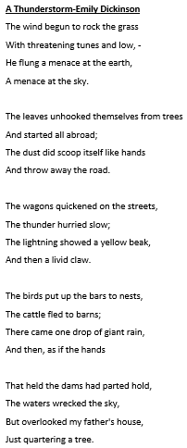
- I can express my own opinion thought and opinions

