Week 6 – Friday – problem solving
Using what you have learnt this week about decimal sequences. Look at the following problem.
See if you can find a pattern/ rule. Look closely at what the difference between each number could be.
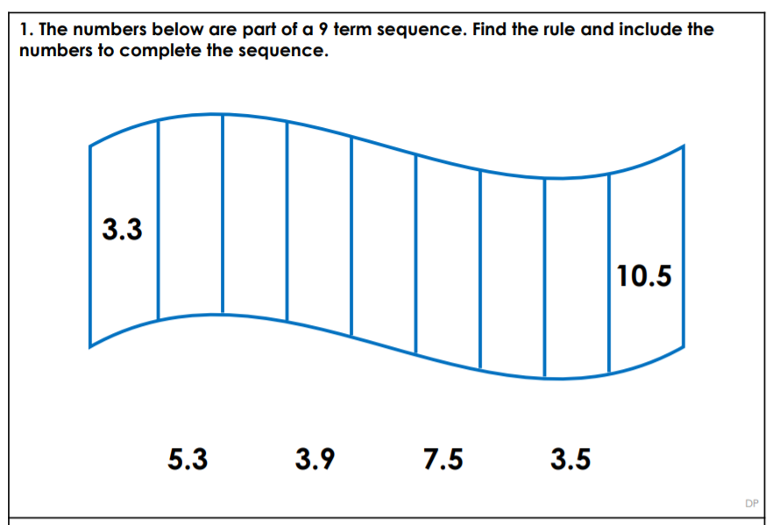
Extention
