**Pupil star of the week**

CC: Oliver Perkins- For all of your wonderful work and enthusiasm this week

BB1: Poppy for working hard at home with her school home learning and also taking on the wildlife trust 30 days wild challenge. It is great seeing all the activities you are doing. Keep it up!

BB2: Amelia O’Shea for all her hard work and creative tea based on our minibeast topic.

GG1/2: Home learning star of the week in Giraffe's class this week is Patrick Karchnak, he has worked hard and sent lots of work to me using class dojo.

HH1/2: Caleb - for some super home learning - keep it up

RR1/2: Kaitlin - For completing every home learning challenge this week! Well done.

FF3/4: Connie who is completing a lot of work on her paper copies. Keep up the good work!

PP3/4: Sahiba For making me smile with your fantastic letter.

FLF3/4: Poppy for showing off her own baking skills and for working hard at home!

DD5: Kai Wardman is our star this week for completing his work and uploading it to google classroom. He has written a super poem describing a dragon. Well done Kai!

DYD5: The home learning star of the week in Dogs this week is Kelly. He has taken a much more enthusiastic approach to his work and has responded to feedback well.

OO6: My home school learning star of the week is Eshal. For her continued hard work at home. Eshal completes all of the daily home learning every day.

**Parent star of the week**

CC: Freddie’s family for all getting involved in Freddie’s learning. Thank you for all of the videos that you share with us on Dojo

BB1: For Editor, Jemimah’s mum who makes learning at home such a lot of fun for Jemimah and her sisters. Your science work this week was amazing!

BB2: Alex Gombe for always supporting Joshua’s learning and for sending fantastic videos.

GG1/2: Dominique Whyte - for supporting both boys to work hard at home, I also love the letter you helped Elijah to write for me, Thank you

HH1/2: For Stacy Wright - for making me smile every time that I speak to you - thank you.

RR1/2: Nosheen Hussain for a lovely phone call with you and Romana this week!

FF3/4: Alex CJ mum who keeps sending work through and who is always working hard

PP3/4: Julia’s mum for good communication and support.

FLF3/4: Nikita’s mum and dad for posting on class dojo and for sending through all of her work through!

DD5: Farzana Kauser, Ahmed’s mum for always being quick to like and respond to our dojo posts and messages as well as supporting Ahmed at home with his work.

DYD5: Mehvish Seemab - For encouraging Riyan to complete his home learning and coming to collect home learning packs. Thank you!

OO6: For Lily’s mum. For her continued support in helping Lily everyday with her home school learning work. Thank you.



**Head Teacher’s comment**

It has been a wonderful yet strange week at school as we have welcomed back our Year 6 and Year 1 pupils. I was so happy to see them as all the staff were and school is beginning to feel like a school again. We have given our bubbles names, a motto and they will be making a flag. It has been wonderful to see the children back in school and thank you to all the wonderful staff for their hard work and energy. You have been fantastic! I hope you have a good weekend and watch out for our star of the week videos this afternoon. Take care and look after yourselves. Mr Tolson

**Positive notes**

Miss Smith:  We have had a lovely week exploring shape through the story Walter’s Wonderful Web

Mrs Pitts: So many children have been learning from home this week and lots of parents have been posting on dojo. What a great start to our new term.

Miss Croft: I have enjoyed seeing receptions creative ideas about our new topic.

Mrs Gibbons:  It has been a busy week helping children settle back in to new routines in school this week, they have all worked really hard and impressed me several times.

Mrs Thompson: I have loved seeing so many children return to school this week.  We are so happy to have you back!

Mrs Wallis: I have loved being back in school and back teaching

Mrs Langley: It has been so good to work with the y6 children this week and to see them relax and settle back in to school life after worrying so much about what it would be like. They have worked like they have never been away and produced lovely work. Well done Y6!

Miss Rosenberg: It has been lovely to be with the Year 6 children this week. Their hard work and determination has been brilliant to see. Well done all.

Mrs Allingham: I have loved seeing some of the year 6 children returning to school and working so hard. Well done everyone.

**Important Notices**

Here are this week’s messages:

1. Remember Reception start on Monday 15th June and Nursery come back on Thursday 18th June
2. If you would like a place for your child in Nursery,Reception, Year 1 or Year 6 please make sure you ring school and contact either Mr Tolson [chris.tolson@academystjames.com](mailto:chris.tolson@academystjames.com) or Mrs Thompson [ruth.thompson@academystjames.com](mailto:ruth.thompson@academystjames.com)
3. If you are a key worker please and would like a place please contact us.
4. As you will have seen the government have announced that Year 2,3,4,5 will not be returning to school until September. We will be continuing our home learning offer.
5. Works packs will be available for collection from school every week. Please come down on a Monday to collect.
6. If you have a FSM these will continue in vouchers for the time being. We will keep you updated if this changes

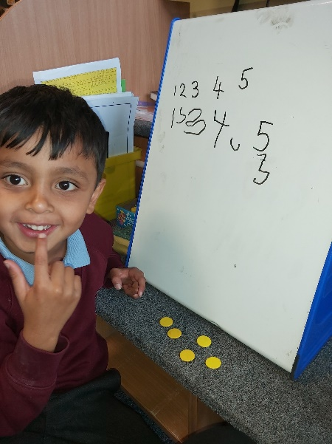

**Photos from this week**

