Adaptation

bbc bitesize - website https://www.bbc.co.uk/bitesize/articles/zjf3rj6

Living things are adapted to their habitats.
This means they have special features that help them to survive.
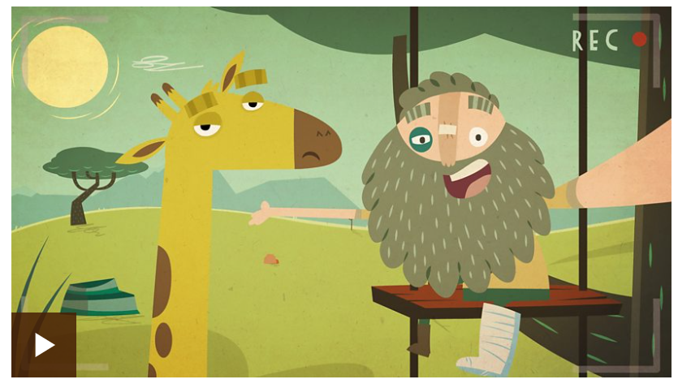
Examples of animals adapted for different environments include:
- African elephant - lives in a hot habitat and has very large ears that it flaps to keep cool.
- Polar bear - lives in a cold habitat and has thick fur to keep warm.
It’s not just animals that are adapted to their environment, plants are too.
A cactus is well adapted for survival in the desert.
They have long roots to collect water from a large area and a stem that can store water for a long period of time.
The animals and plants in one habitat are suited to live there and may not be able to survive in other habitats.
When a habitat changes, the animals and plants that live there are affected.
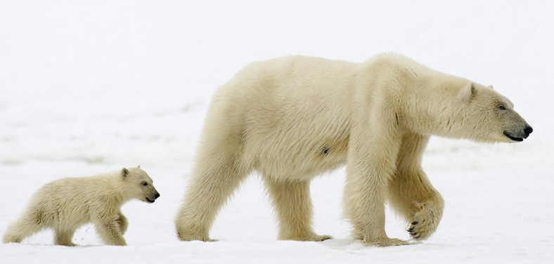
Animals that are good at adapting will be good at surviving and reproducing.
- The Texas blind salamander has adapted to have no eyes because it doesn't need them to survive in its habitat - a pitch black cave.
- The arctic fox has dark fur in the summer but its fur changes to white to blend in with the snow in the winter.
- The desert fox has very large ears. Along with its thin coat, these features help it keep cool in the heat of the desert.
- The cuttlefish can change colour in the blink of an eye to match its environment under the water.
Complete the quiz either on line or from the attached documents – Home learning wk 12 Adaptation.

