Art - Roy Lichtenstein
Lesson 2

You are going to create your own self-portrait in the style of Roy Lichtenstein.

Follow the steps below and see what you can create!

This activity works best with brightly coloured paper. If you do not have any, simply use plain paper. You will also need some coloured pencils.

- Draw a self-portrait of yourself including your face and shoulders. If you have a photograph of yourself, you could always trace over this. Make sure you have parent/guardians permission first! Remember – the more detail you include, the better the outcome of your picture.

- Once you are happy with the outline, use a permanent black pen to go over all the lines. You can emphasise certain parts of your face by creating thicker black lines. Colour in your face and features.

- Cover your face with circles; these can be as large or small as you wish, but not the size of your face! You need to colour every circle with a strong colour that will stand out on your face.

- Review your drawing. Do you like it? How would you improve next time?

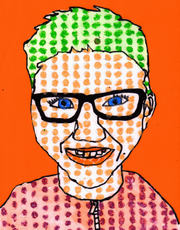
Here is an example:

