Creation/Fall – Lesson 3
Last week, we read the first part of the Creation story and noticed that the word ‘good’ was used six times in a short passage.
Today, we are using Genesis 1 (26-31) from the Bible. Read the text, highlight the times good is used. What is being described as good in this part of the Creation story?

Genesis 1 (26-31)
26 Then God said, “Let us make mankind in our image, in our likeness, so that they may rule over the fish in the sea and the birds in the sky, over the livestock and all the wild animals,[a] and over all the creatures that move along the ground.”

27 So God created mankind in his own image, in the image of God he created them; male and female he created them.

28 God blessed them and said to them, “Be fruitful and increase in number; fill the earth and subdue it. Rule over the fish in the sea and the birds in the sky and over every living creature that moves on the ground.”

29 Then God said, “I give you every seed-bearing plant on the face of the whole earth and every tree that has fruit with seed in it. They will be yours for food. 30 And to all the beasts of the earth and all the birds in the sky and all the creatures that move along the ground—everything that has the breath of life in it—I give every green plant for food.” And it was so.

31 God saw all that he had made, and it was very good. And there was evening, and there was morning—the sixth day.

Christians see these as God’s instructions to human beings, from the first book of the Bible.
What instructions does God give to humans for treating the Earth as God’s good creation? How should human beings treat God’s Creation?
Here are some suggestions. Choose the MOST likely and the LEAST likely meaning. Add your own idea for the last statement.

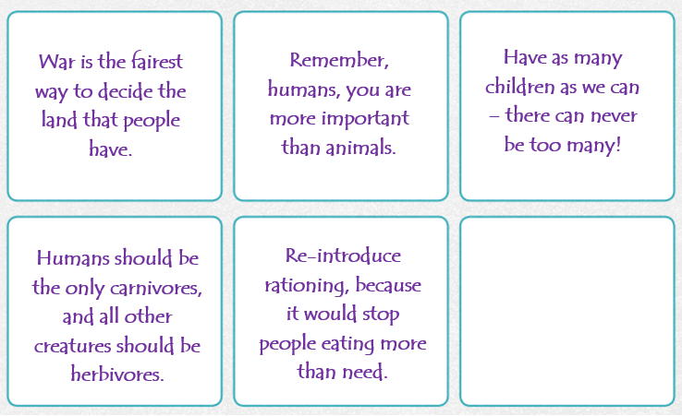
Now, explain why you ordered the statements in this way.

Re-introduce rationing, because it would stop people eating more than need.

Humans should be the only carnivores, and all other creatures should be herbivores.

Think of something you have made. What instructions would you give someone, to help them know how to look after it?

