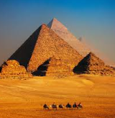
How and why were the Pyramids made?
https://www.dkfindout.com/uk/history/ancient-egypt/pyramids/
https://www.bbc.co.uk/bitesize/clips/z849wmn

The pyramids in Egypt are famous physical features and dictate the landscape of Egypt.
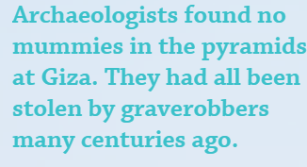
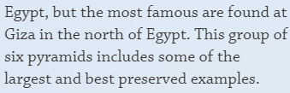
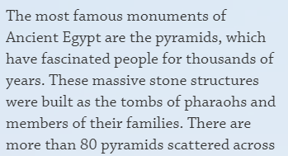

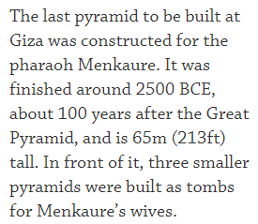
Pyramid of Menkaure Pyramid of Khafre
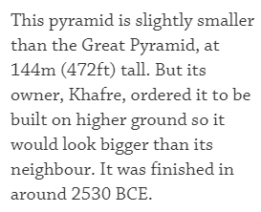

The Great Pyramid
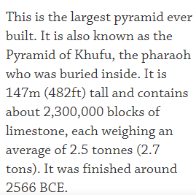
Curriculum tasks
Can you create your own quiz about the facts about pyramids, which you can share on classroom with your friends?

What is the purpose of the pyramids? Why were they built?

How did the physical location of the River Nile help with the building of the Pyramids?

