Wednesday 10th June
English – Xfilious – Describing a Dragon
In the poem, Xfilious, the author describes the dragon in detail. They focus on one feature of the dragon at a time. Look at the picture of the dragon below. How would you describe it?

Start at number 1 and make a list of words or phrases that you could use to describe that feature of the dragon.
Example:
- The tail – thrashing, pointy, lengthy, uncontrollable, scaly, whipping, sharp, lizard-like, clumsy, elongated, leathery, toxic, terrifying
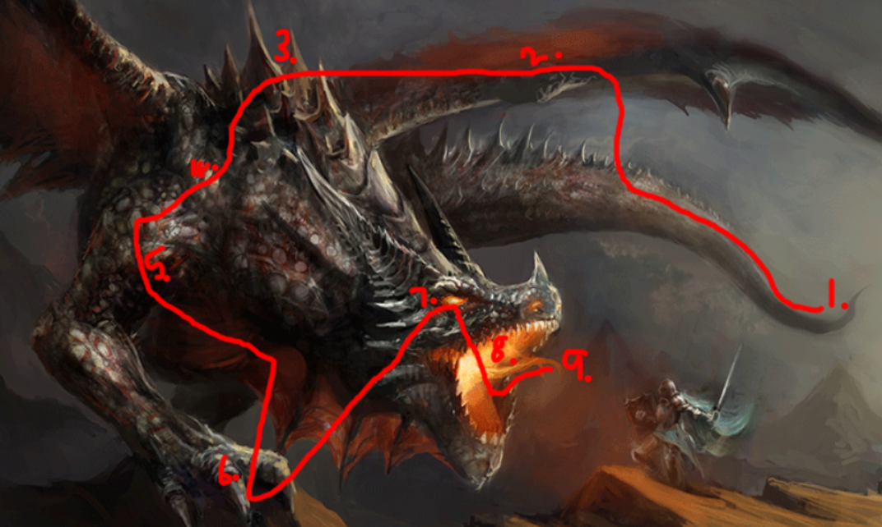
Make a list for:
- The tail
- The wings
- The spine/ back
- The scales
- The legs
- The talons
- The eyes
- The mouth
- The breath/ fire

