English work w/c 8.6.2020
This week you will be researching about Ancient Greece. You will the write and perform your own Kenning poem about a Spartan Warrior. We have written lots of Kenning poetry (if you can’t remember, look back at our Google Classroom as all the information is on there!)
Monday | Tuesday
English: This week you are going to write your own Kenning poem about Ancient Greece!  Can you use the link to research all about Ancient Greece?  https://www.bbc.co.uk/bitesize/topics/z87tn39/articles/zxytpv4  Can you create a mind map of what you’ve learnt?  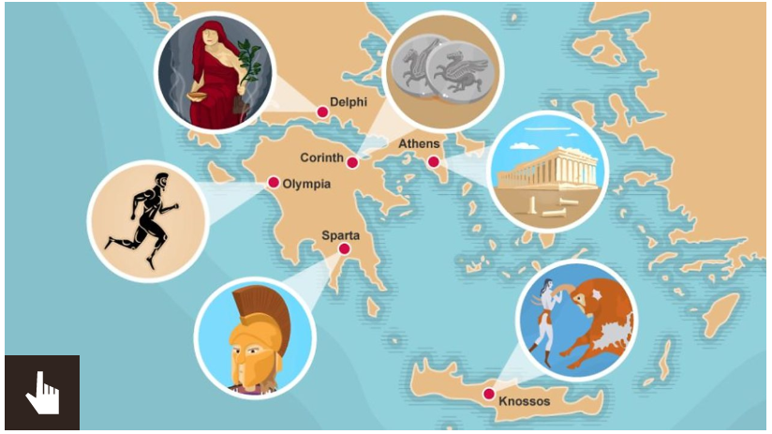 | Using your mind map yesterday did you learn about the soldiers? These were called Spartans!  Use the link below  https://www.bbc.co.uk/bitesize/topics/z87tn39/articles/zckr4wx  I learnt that they were strong and fearless!  ruthless fighters angry strong men fearless  intimidating warrior feared  Can you create your own word mat to describe the  Spartan soldiers?
Wednesday | Thursday
Can you draw your own Spartan soldier? Label him as well please! (Using what you learnt yesterday!)  https://www.dkfindout.com/uk/history/ancient-greece/sparta/  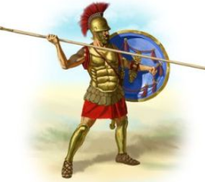 | After 3 days of research, please write your own Kenning  Poem about the Spartan soldier. Here is an example.  Strong-fighter  Feared- warrior  Pain-inflictor  Wound- intender  Ruthless- killer  Armour-wearer  Spear- thrower
Friday
Performance time!!

Please perform your Spartan Kennings poem. Can you add props? Use the shield which you have made in
art?

