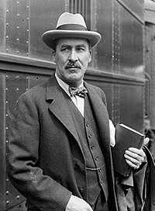
Date:______________________________________________
LI: to be able to plan and draft, evaluate and edit an informal letter
I will be successful if:
- I can use the correct layout for a letter
- I can write as a character
- I can use informal language
- I can include a range of sentence types (fronted adverbial, relative clause, subordinate conjunctions, expanded noun phrases)
- I can use a range of adverbs (for time and for detail)
I am writing to:

Why am I writing?

What are the main things I want to say?

Who is the letter from?

