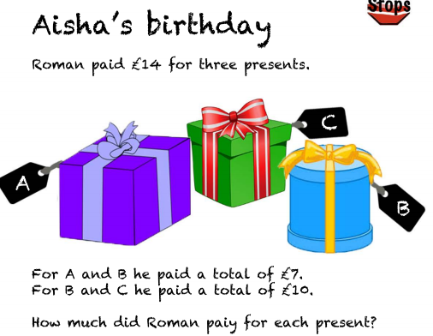**Problem Solving**

A £3 + B £4 = £7

B £4 + C £6 = £10

£10 + £7 = £17 The total needs to be £14 so that means this answer is **incorrect** because the total of the numbers was £17

A £4 + B £3 = £7

B £3 + C £7 = £10

Present A is £4 Present B is £3

Present C is £7

A + B = £7 B + C = £10

4 + 3 + 7 = £14

This answer is **correct**

1. 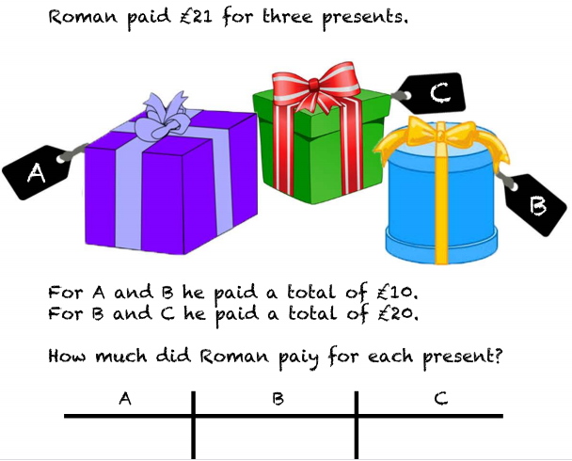

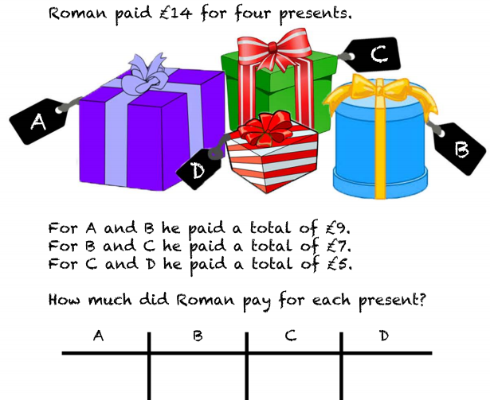

1. 