Friday 26th June
Problem solving
Have a look at this problem –which of the problem solving strategies might help you?
- Trial and error
- Trail and improvement
- Act it out / model it
- Draw a diagram
- Make a table/ list
- work backwards
- find a pattern
- Use algebra

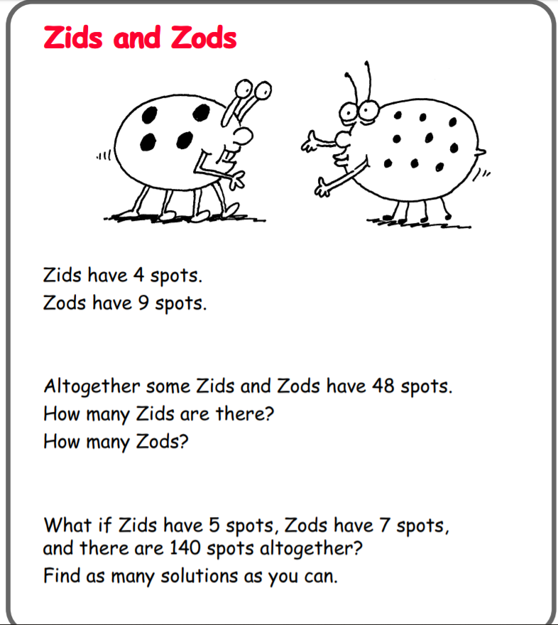
If you need a clue as to where to start, watch the video:
https://www.loom.com/share/1c5bf3c623c3409397d73438e03175c2
Don’t forget to upload your solutions to dojo or classroom!

