Friday 3rd July 2020
This week we are writing a conquering the monster story about Ancient Greek mythical creatures. For today’s lesson, please carry on learning the WAGOLL which you started to learn on Tuesday, but we will also learn how to write descriptively.

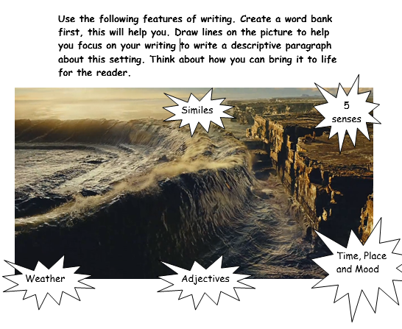
Yesterday you wrote descriptively about a mythical creature. Today you are going to write a descriptive paragraph about a mythical setting.

Nouns | Verbs | Adjectives | Weather | Time, place and mood | 5 senses | Similes
Sea  Mountain | Splashing  hitting
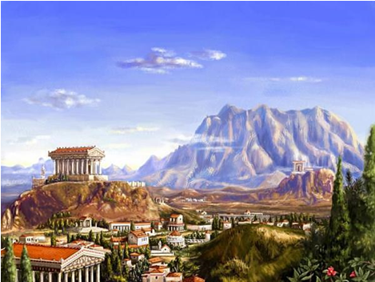

Nouns | Verbs | Adjectives | Weather | Time, place and mood | 5 senses | Similes
Parthenon
mountain

