Friday 3rd July 2020
A consecutive number is the number that follows. So for example
2 consecutive numbers are 3 and 1
6 consecutive numbers are 5 and 7
10 consecutive numbers are 9 and 11
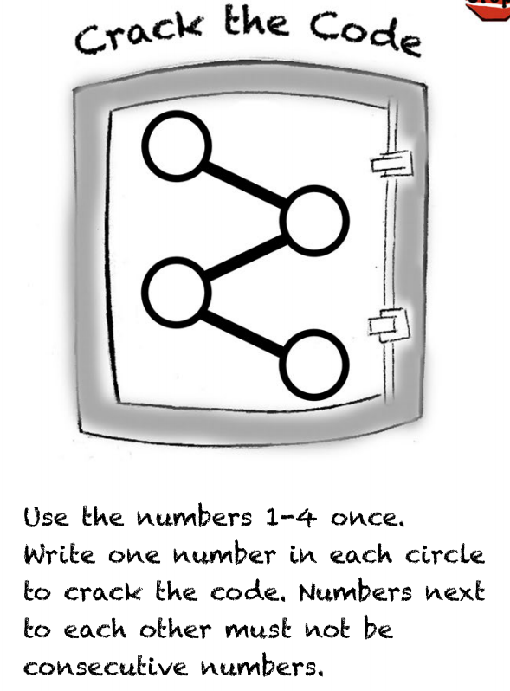
1st attempt
1 – 2 – 4 – 3
This is incorrect as 1 and 2 are consecutive number and 3 and 4 are as well.
2md attempt
2-4 -1 -3
This is correct as neither of the numbers they are next to are consecutive numbers.

