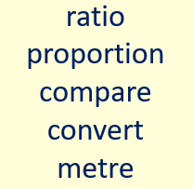

Please use the powerpoint which is attached to help you. This is a new area of maths, which we have not covered.
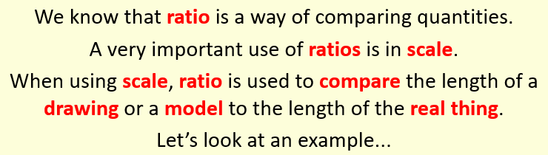

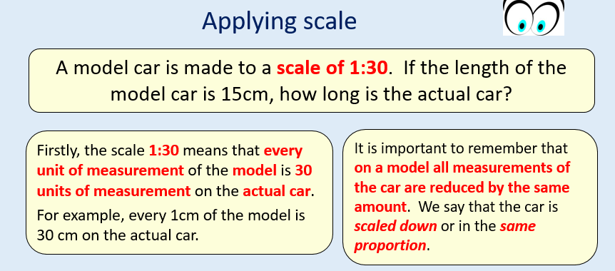

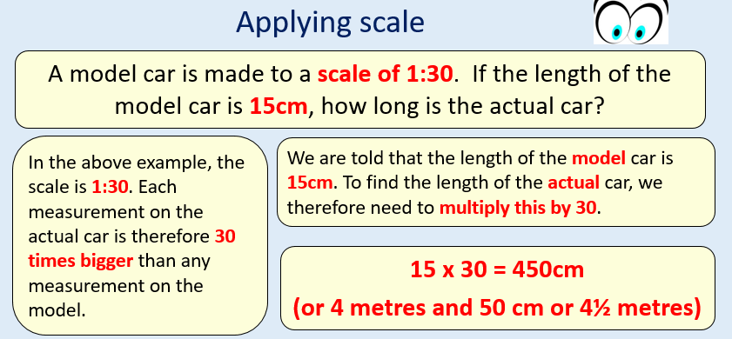

Friday
- A model of a bus is made to a scale of 1:30. If the model has a length of 30 cm, what is the length of the actual bus? Give your answer in metres.

- An aeroplane has a wingspan of 60 metres. A model of it is made on a scale 1:50. How big is the wingspan on the model?

- Gary makes a model of a house. All the measurements of the actual house are ten times bigger than the measurements of the model. What is the scale of his model?

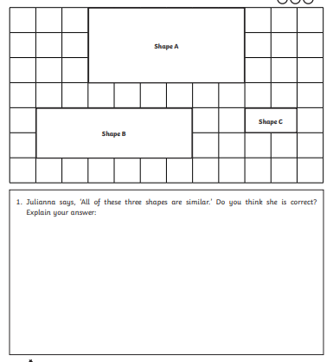

https://www.bbc.co.uk/bitesize/guides/znnycdm/test
Can you test your knowledge of ratio and proportion? How did you do? Can you keep improving your score?

