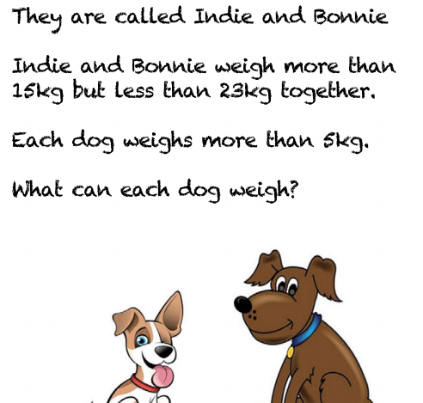**Problem Solving**

Indie = 6kg

Bonnie = 6 kg

6kg + 6kg = 12kg **this does not work as 12 is less than 15.**

Indie = 10kg

Bonnie = 8kg

10kg + 8 kg = 18kg. **This works**

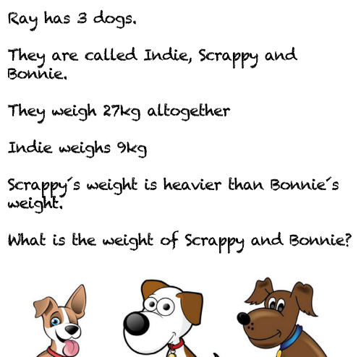

Indie = 9kg

Scrappy = 7kg

Bonnie – 11kg

9 + 7 + 11 = 27kg **but Scrappy should be heavier than Bonnie so this is incorrect.**

Indie = 9kg

Scrappy = 11kg

Bonnie = 7kg

9 + 11 + 7 = 27kg **Scrappy is heavier than Bonnie and Indie is 9kg so this is correct**

Your questions are on the next page

1. 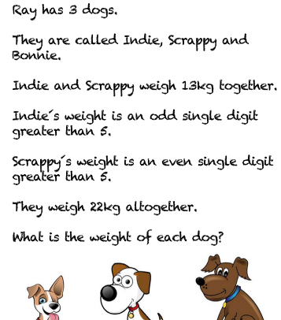
2. 